`Masculinity Influencer Content in Nigeria and Kenya

Executive Summary
Purpose of the study
This report examines masculinity-focused creator content in Nigeria and Kenya. The study focuses on media content that explicitly or implicitly addresses masculinity, with the objective of identifying core narratives, strategies, and appeals that drive engagement, particularly among adolescent boys and young men. The analysis treats creator content as a public site where norms about men, women, relationships, emotion, provision, authority, sexuality, fatherhood, and violence are articulated, reinforced, negotiated, and sometimes challenged.
For each selected influencer or creator-hosted source, we analysed sampled media outputs to understand core topics, themes, narratives, sentiments, and rhetorical strategies used in communicating about masculinity. The content analysis surfaces how different narratives, themes, and topics cluster together in the media outputs of studied influencers and how different entry points into this content might function for playbook creation.
Study scope and content sources
Country | Content sources studied | Gender norm categories addressed | Primary content platforms
Nigeria | Banky/MENtality, Ebuka Obi-Uchendu/MENtality context, Deyemi, Agba John Doe, Shola, Wizarab, and related source context | Provision, accountability, rape and abuse, male trauma, marriage hierarchy, sexual morality, women as dependent, anti-feminist grievance | YouTube/podcast, X/Twitter, creator posts
Kenya | Rixpoet/Onyango, Eddy Kimani, Philip Karanja, Amerix, Andrew Kibe | Fatherhood, trauma, peace, purpose, mental health, submission, discipline, status, sexual entitlement, GBV accountability | YouTube, TikTok, Instagram, X/Twitter

Key methods and validation snapshot
- Full content corpus: 704 sampled media pieces: 310 Nigeria and 394 Kenya.
- Focused content validation sample: 400 item-level rows: 200 Nigeria and 200 Kenya.
- Human coding assignments used for reliability: 480 content assignments, including single-coded, pairwise-overlap, and all-coder calibration rows.
- LLM coding, EDA analysis, QA, and report update model: GPT-5.5.
- Verified LLM codebook checks: 0 blank IDs, 0 duplicate IDs, 0 schema issues after normalization, and 0 conditional-logic issues after verification.

Content Source Creators and Primary Social Platforms
Country | Creator | Orientation | Primary Social URLs
Kenya | Eric Amunga (Amerix) | Regressive | x.com/amerix ; amerix.co.ke
Kenya | Andrew Kibe | Regressive | @kibeandy (X) ; YouTube/@AndrewKibe
Kenya | Philip Karanja | Progressive | @phil_director (IG) ; philittv.com
Kenya | Onyango Otieno (Rixpoet) | Progressive | @rixpoet (IG) ; YouTube/@OfficialRixpoet
Kenya | Eddy Kimani | Progressive | @eddykimani (TikTok) ; @eddykimani (IG)
Nigeria | Banky Wellington | Progressive | @bankywellington (IG) ; YouTube/@BankyW
Nigeria | Deyemi Okanlawon | Progressive | @_deyemi (X) ; @deyemitheactor (IG)
Nigeria | Wizarab | Regressive | @Wizarab10 (X)
Nigeria | Shola | Regressive | @itsSh0la (X)
Nigeria | Agba John Doe | Regressive | @jon_d_doe (X)
Nigeria | Ebuka Obi-Uchendu | Progressive | @ebuka (IG) ; @Ebuka (X)

In the Nigeria content corpus (310 snippets), provider role and economic pressure appeared in 128 snippets (41.3%), present across both orientations. Relationship and gender-dynamic themes, spanning marriage, submission, sexual entitlement, and blame, appeared in 167 of 310 Nigeria snippets (53.9%), with a sharp directional split: 71.7% of regressive Nigeria snippets carried these themes versus 31.4% of progressive. Emotional expression and men's inner life appeared in 46 of 310 Nigeria snippets (14.8%), concentrated in progressive content (25.5%) and largely absent from regressive content (6.4%). Fatherhood and parenting appeared in 44 of 310 Nigeria snippets (14.2%), almost entirely in progressive content (30.7% vs. 1.2% in regressive). Across the full 704-snippet corpus, provider pressure and relationship themes were present in both countries; emotional expression and fatherhood showed the sharpest orientation gap in both corpora.
Thematic analysis findings
- Across both countries, masculinity discourse is organised around pressure. Creators repeatedly return to provision, respect, emotional control, sexual access, marriage, fatherhood, and status. The ideological difference lies in how creators explain these pressures and what solution they offer.
- Progressive creators tend to frame masculinity as responsibility, healing, self-reflection, protection without control, and accountability. Regressive creators tend to frame masculinity as hierarchy, discipline, market value, emotional hardness, sexual entitlement, and suspicion of feminism or women.
- Provider pressure is the most shared entry point. It appears across progressive and regressive content, but the normative direction differs. Progressive content asks how economic pressure harms men and relationships. Regressive content converts provision into authority, entitlement, or proof of male superiority.
- Relationship content is the main site where gender hierarchy becomes persuasive. Regressive creators often use everyday anxiety about dating, cheating, divorce, false accusation, sexual history, or disrespect to make broader claims about women and feminism.
- Emotional life is the clearest orientation split. Progressive content, especially in Kenya, treats vulnerability, trauma, and healing as mature masculine work. Regressive content more often treats therapy, softness, or emotional openness as weakness unless redirected into discipline and control.
Engagement metrics (likes, shares, reply counts) were reviewed as contextual cues during source selection only. This report is not a completed standardized engagement-rate, velocity, or virality analysis; platform engagement signals are noted where available and are not treated as primary analytic outputs. Post-level source content engagement metrics are reported in Section 3.4 of the Audience Analysis Report. A standardized rate/velocity/virality analysis with systematic cross-variable correlations is outside the current measurement scope; this report presents available post-level metrics and pattern-level observations as a partial completion of the engagement scope.
Figure 1. Content corpus overview by country and orientation.
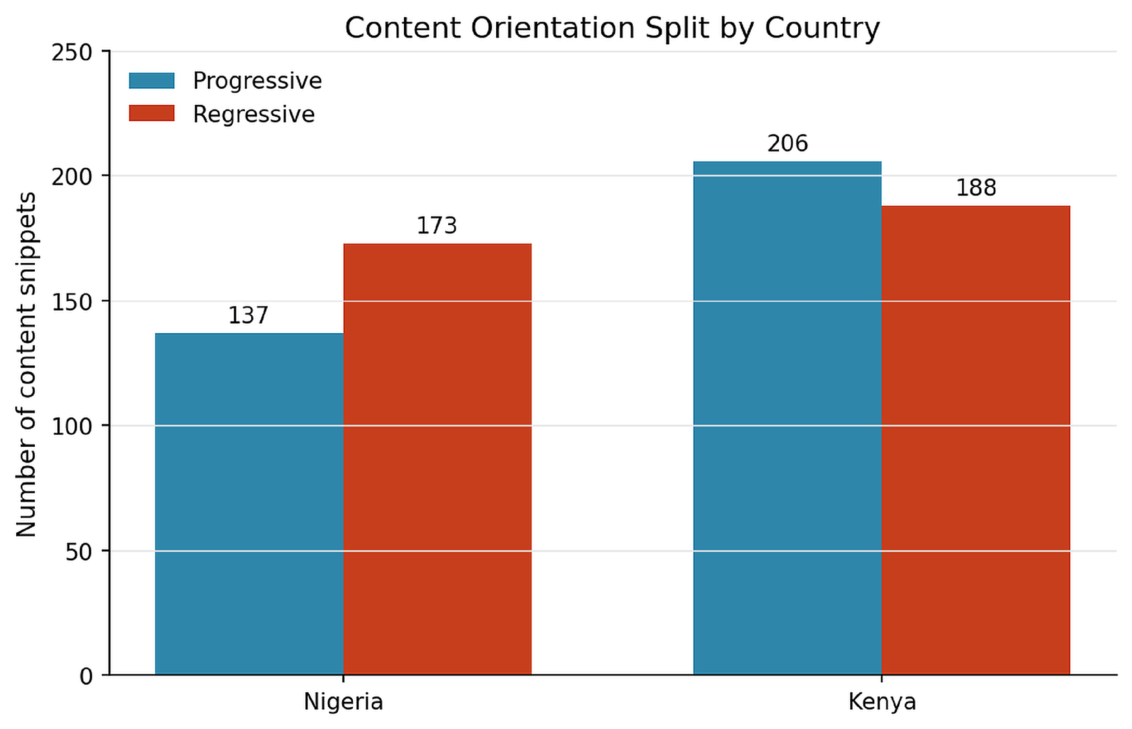

Figure 2. Content analysis pipeline used for source capture, filtering, LLM analysis, human coding, and validation.
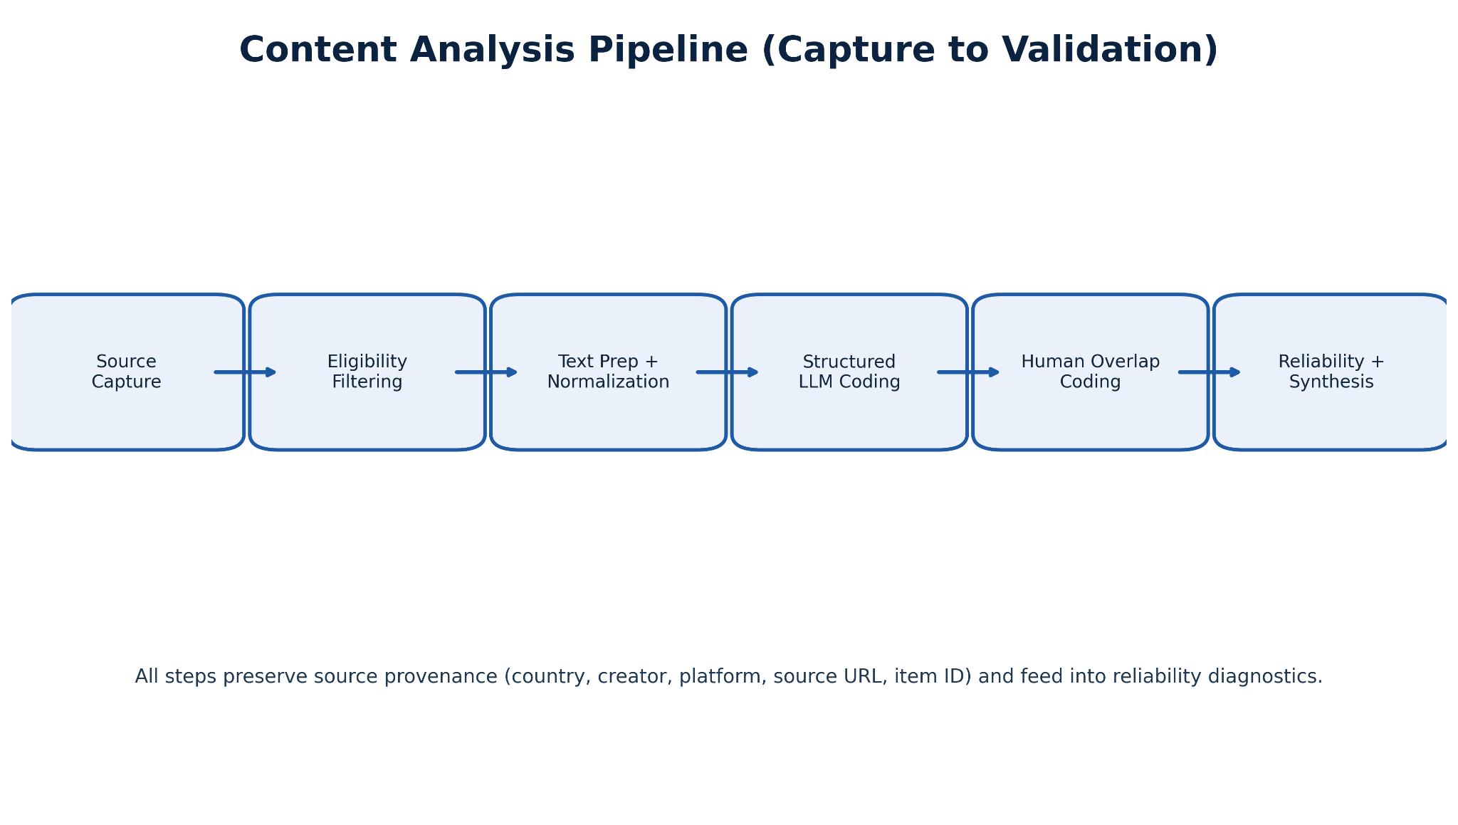

1. Introduction

1.1 Background and Motivation
This study is part of a larger project documenting how gender norms related to masculinity are produced and circulated in popular digital creator content in Nigeria and Kenya. The project is invested in understanding what normative messages audiences are exposed to in high-reach masculinity-focused creator spaces, and how those messages differ across country contexts, platform environments, and ideological orientations. Nigeria and Kenya were selected as primary country cases because both feature active social media discourse on gender roles, provision, accountability, and anti-feminist reaction, but through distinct platform structures and creator communities.
We treat creator content not as a reflection of individual opinion but as genre-specific, platform-shaped discourse. Creators who post about female submission on X/Twitter, or who discuss men's healing on YouTube, are performing within recognizable genre conventions that shape what can be said, what resonates, and what spreads. These conventions are the primary unit of analysis, not individual creator psychology or intent. The project focuses specifically on the overlap between self-help, relationship advice, social commentary, faith, fatherhood, men's mental health, anti-feminist discourse, and explicitly misogynistic claims, because harmful gender norms travel most effectively through advice, personal testimony, moral warning, and claims about what real men or good women should do (Connell and Messerschmidt, 2005; Kimmel, 2010).
Taken together, the Nigeria and Kenya design allows comparison of whether masculinity pressure themes travel across different media ecologies, or whether each country's content has a distinctive rhetorical logic tied to its dominant platform format. These questions have direct relevance to playbook design: interventions that work in one media environment may not transfer to another without adaptation.

1.2 Content and Platform Selection Rationale
Content selection followed a purposive, high-signal scope protocol. Creators were chosen using four criteria: topical relevance to masculinity discourse, sustained output volume, traceable platform presence, and orientation balance (progressive and regressive). The goal was a corpus that captures the range of how masculinity is framed in high-reach creator spaces, not a representative sample of all creator content in either country.
Platform selection reflected both data quality and discourse structure. X/Twitter was prioritized for Nigeria because it supports high-frequency creator positioning and generates bounded, codeable text units suitable for structured analysis. Nigerian X discourse is particularly concentrated in relationship-marketplace commentary, accountability debates, and anti-feminist positioning. YouTube and longform podcast material was prioritized for Kenya because progressive creator output was concentrated in video format, and longform media provides richer context for framing analysis. Kenyan YouTube content includes substantial therapeutic masculinity material, fatherhood accountability framing, and peace-and-purpose narratives that are less common in the Nigerian X corpus. Scope decisions were applied before any coding began. The final Nigeria corpus of 310 snippets spans YouTube, podcast, and X content from six creators. The final Kenya corpus of 394 snippets spans YouTube, TikTok, and X content from five creators. Platform mix is reported as a design condition, not a limitation.
Table 1. Creator and source selection logic
Country | Orientation | Creator or source | Why included | Main source type
Nigeria | Progressive / accountability | Banky Wellington | Faith, family, partnership, emotional maturity, and accountability. Useful as a longform case where masculinity is framed through care and relational responsibility. | YouTube / podcast material and creator-linked source context
Nigeria | Progressive / accountability | Ebuka Obi-Uchendu / MENtality context | High-reach Nigerian longform source context for public conversation about men, emotion, marriage, and public responsibility. | YouTube / podcast source context
Nigeria | Progressive / accountability | Deyemi Okanlawon | Rape accountability, anti-deflection messaging, male trauma, and public debate over gendered responsibility. | X/Twitter posts and thread context
Nigeria | Regressive / manosphere-adjacent | Agba John Doe | Relationship-marketplace reasoning, marriage hierarchy, fidelity, and gendered authority. | X/Twitter posts and thread context
Nigeria | Regressive / manosphere-adjacent | Shola | Men-as-prize framing, status, surname/lineage claims, women-as-dependent narratives, and anti-feminist claims. | X/Twitter posts and thread context
Nigeria | Regressive / manosphere-adjacent | Wizarab | Sexual morality, gendered blame, grievance narratives, and accusations against women around family and relationships. | X/Twitter posts and thread context
Kenya | Progressive / mental health | Rixpoet / Onyango Otieno | Trauma, fatherhood, abuse, healing, vulnerability, and intergenerational emotional harm. | YouTube interviews / creator-hosted video material
Kenya | Progressive / mental health | Eddy Kimani | Peace, purpose, performance culture, men leaving chaos, depression, marriage breakdown, and rebuilding. | TikTok, YouTube, shortform creator material
Kenya | Progressive / GBV accountability | Philip Karanja | Fatherhood, girls safety, GBV/femicide accountability, and men taking responsibility for prevention. | YouTube, Instagram, creator-led social material
Kenya | Regressive / manosphere-adjacent | Amerix | Submission, discipline, status, provision, hierarchy, respect, and female dependence. | X/Twitter posts and thread context
Kenya | Regressive / manosphere-adjacent | Andrew Kibe | Provocation, objectification, sexual variety, anti-feminist humor, and cynical male advice. | X/Twitter posts and creator-linked social material

1.3 Research Questions
- The content track asks: which masculinity frames are most recurrent across the corpus; how framing differs by country, creator, and platform context; which narratives are predominantly regressive versus progressive under the final codebook; and where hybrid or internally contradictory framings appear within the same creator stream.
- Which topics and narratives cluster together across creators, countries, and orientation groups?
- What rhetorical strategies do creators use to make masculinity narratives persuasive or shareable?
- How do progressive and regressive creators differ in their treatment of provision, emotion, relationships, sexuality, fatherhood, and status?
- Which content features appear most useful for future playbook creation and intervention design?

1.4 Creators and Platforms
The final cohort includes 11 creators across Nigeria and Kenya with intentional orientation balance and platform diversity. Creator-level source provenance is retained through source URL fields and creator metadata so every coded segment remains auditable. Platform mix is interpreted as an analytic design condition of purposive social listening and is therefore reported transparently in findings rather than treated as a representative population distribution.

1.4.1 Content Creators and Source Profiles
Six Nigerian and five Kenyan creators were selected through purposive sampling to balance progressive and regressive orientations, country, platform, and format. Profile cards below show each creator's orientation, key themes, and public platform handles. Pseudonymous or anonymous accounts are shown with initials only.
Creator / Source Handle and Link Reference
Creator / Source | Country | Orientation | Platform | Handle / Source Link | Notes
Banky Wellington | Nigeria | Progressive | YouTube / Instagram | @bankyw (IG) ; @BankyW (X) | Public figure; MENtality podcast
Ebuka Obi-Uchendu | Nigeria | Progressive | YouTube / Instagram | @ebuka (IG); @Ebuka (X) | BBNaija host; longform masculinity content
Deyemi Okanlawon | Nigeria | Progressive | X / Instagram | @deyemitheactor (IG) | Actor; accountability and fatherhood focus
Agba John Doe | Nigeria | Regressive | X (Twitter) | @jon_d_doe | Pseudonymous; marriage-hierarchy content
Shola | Nigeria | Regressive | X (Twitter) | Shola 👑 (@itsSh0la) / Posts / X | Pseudonymous; handle unverified for public release
Wizarab | Nigeria | Regressive | X (Twitter) | @Wizarab10 | Pseudonymous; sexual-marketplace content
Rixpoet / Onyango Otieno | Kenya | Progressive | YouTube / Instagram | @rixpoet (IG) | Mental health workshop; spoken-word poet
Eddy Kimani | Kenya | Progressive | X / Instagram | @Eddykimani (X) | Media personality; vulnerability and fatherhood
Philip Karanja (Director Phil) | Kenya | Progressive | YouTube / Website | Phil Director - YouTube | Filmmaker; GBV / femicide accountability content
Eric Amunga (Amerix) | Kenya | Regressive | X (Twitter) | @amerix | Discipline-hierarchy content; #MasculinitySaturday
Andrew Kibe | Kenya | Regressive | YouTube / X | @AndrewKibe (YT) | Former radio presenter; anti-feminist commentary

1.5 Theoretical Framing
Three analytic concepts organize how findings are interpreted. The first is hegemonic masculinity (Connell and Messerschmidt, 2005), used here descriptively to name the recurring pattern in which authority, provision, emotional restraint, and relational dominance are treated as markers of legitimate manhood. The analytic question is not whether a given creator subscribes to this frame as a belief system. The question is whether their content reproduces, challenges, or selectively modifies this pattern at the level of narrative and rhetoric.
The second concept is platformed self-presentation (Butler, 1990; Marwick and boyd, 2011). Creator content is treated as strategic identity work shaped by platform affordances and audience feedback loops. X/Twitter rewards short, shareable, high-affect positioning; YouTube rewards narrative depth and personal testimony. These structural conditions shape how masculinity is performed regardless of creator intent, which is why platform context is treated as an analytic variable throughout the findings.
The third concept is hybrid masculinity (Bridges and Pascoe, 2014), which captures the contradictory co-occurrence that runs through both corpora: care-oriented language alongside hierarchy claims, vulnerability alongside entitlement, progressive framing alongside relational control. Identifying these contradictions is analytically useful because they mark the specific points where a playbook or intervention could introduce alternative framing without requiring wholesale narrative rejection. The sample is purposive and high-signal; findings are interpreted as pattern-rich evidence about narrative construction in influential digital subpublics, not as population prevalence estimates.
Together, these frameworks foreground structure, performance, and contradiction rather than individual creator psychology. Single-creator deviation from a pattern is noted but not treated as the primary unit of interpretation. The analytic interest is in patterns that recur across creators and contexts, which are more likely to reflect shared genre conventions or ideological common ground than individual expression.

2. Methods

2.1 Data Sources and Collection
Nigeria content data was collected from six creators across three platforms. The three progressive creators (Banky Wellington, Ebuka Obi-Uchendu, Deyemi Okanlawon) contributed content primarily from YouTube, podcast, and X. The three regressive creators (Agba John Doe, Shola, Wizarab) contributed content primarily from X/Twitter. A total of 310 snippets were retained after scope filtering: 137 progressive (44.2%) and 173 regressive (55.8%). Kenya content data was collected from five creators. Three progressive creators (Eddy Kimani, Philip Karanja, Rixpoet/Onyango Otieno) and two regressive creators (Eric Amunga/Amerix, Andrew Kibe) contributed to a final corpus of 394 snippets: 206 progressive (52.3%) and 188 regressive (47.7%).
Collection used Apify actor workflows for X/Twitter timeline and thread extraction, URL-based capture for YouTube episodes and captions, and direct post capture for Instagram and TikTok items meeting predefined traceability criteria. Source URL, platform, creator, and country metadata were standardized at ingest and preserved through all downstream processing steps. Every final coded row can be traced to its original source artifact and retrieval context.
All final coded datasets, raw data files, and codebooks are archived on the project repository: GitHub: Gates-Manfluencer-Project
The complete codebase, scripts, analysis notebooks, datasets, and codebooks for this project are maintained on the project GitHub repository. github.com/sushildalavi/Gates-Manfluencer-Project
Table 2. Content data source construction
Layer | Content analysis implementation
Raw source capture | Creator media outputs, official posts, longform video or podcast material, social posts, and public source context.
Text preparation | Transcripts, captions, post text, and creator snippets were standardized into analysis-ready records.
Scope retention | Items were retained when they explicitly or strongly implicitly addressed masculinity, men, women, gender norms, relationships, provision, emotion, sexuality, accountability, or violence.
Country balance | The final corpus preserves cross-country comparison while reflecting different platform ecosystems and source availability.

2.2 Data Processing Pipeline
The pipeline followed a fixed five-stage sequence. First, raw capture and source logging: all collected items were stored with source URL, platform, creator tag, and collection timestamp. Second, canonical field mapping: creator-specific column structures were harmonized into a standard schema with a consistent set of core fields. Third, text normalization and de-duplication: transcript extraction for YouTube and podcast material used Gemini 2.5-Flash (Google) for video-to-text conversion, with subsequent normalization for Pidgin English, Yoruba, Igbo, Swahili, and Sheng-inflected text. Fourth, scope eligibility filtering: the project keyword framework was applied as a high-recall lexical pre-screen, followed by LLM-based scope confirmation for borderline items. Fifth, provenance preservation: source URL fields were retained at every transformation step. [NLC Proposed Keywords]

Figure 3. Content preparation and transcription workflow visual.
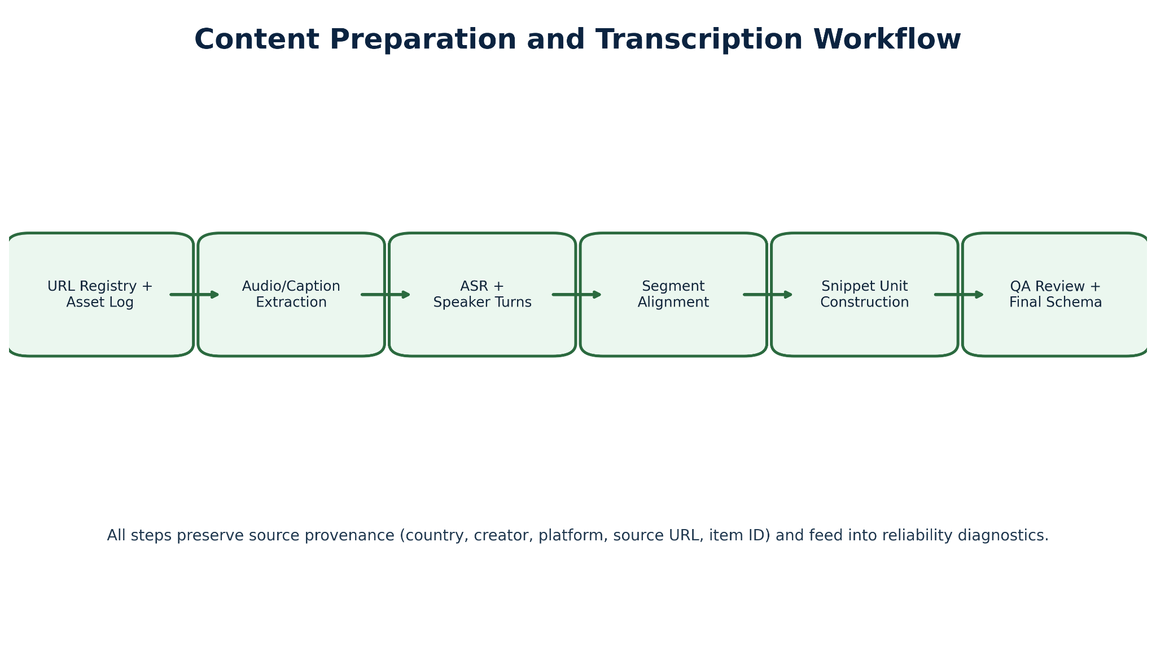

2.3 Thematic Priorities
Thematic priorities were defined around six substantive areas corresponding to the study's research questions. Provider burden and economic pressure: whether masculinity is tied to income and resources and whether that link creates entitlement or obligation. Male authority and leadership: whether authority is framed as earned, given, or simply asserted. Emotional openness versus suppression: whether men are encouraged toward vulnerability and healing or toward stoicism and emotional restraint. Accountability narratives: whether responsibility for harm is accepted, deflected, or reversed onto women. Gender-role prescription: how creators frame what men should do and what women owe men. Misogyny intensity: whether hostility is ambient, explicit, structural, or absent. These priority areas were designed to capture the specific axis of norm production and contestation most relevant to intervention design, not to describe all possible content themes.
Thematic classification was paired with sentiment analysis. Themes discussed predominantly in neutral or positive terms were interpreted as relatively more acceptable or less contested. Themes that consistently clustered with negative sentiment, particularly when associated with contempt, ridicule, or moral condemnation, were interpreted as more contested. Acceptability was assessed through systematic theme-by-sentiment patterns, not through isolated examples.
Table 3. Content thematic priorities
Priority area | What the analysis tracked
Provision and status | Whether masculinity was tied to income, resources, leadership, respect, social rank, or sexual access.
Emotional life | Whether men were encouraged to be vulnerable, heal, speak, withdraw, harden, dominate, or avoid therapy.
Relationships and sexuality | How creators framed marriage, dating, cheating, sexual history, fidelity, divorce, false accusation, and consent.
Fatherhood and care | Whether male responsibility appeared as private care, public accountability, protection, or control.
Gender hierarchy and misogyny | Whether content reproduced submission, women-as-dependent frames, anti-feminist claims, objectification, or blame narratives.
Progressive counter-narratives | Whether content offered alternative scripts around accountability, shared care, emotional maturity, and community responsibility.

2.4 LLM-Assisted Analysis
We assigned structured labels to each content snippet using a closed-set schema with option-locked fields and conditional logic rules aligned to the final codebook. Content snippets could receive multiple theme labels when relevant. Sentiment was standardized to four categories (positive, neutral, negative, unclear), and emotion labels were drawn from a fixed set to support comparability across countries. We ran LLM inference using deterministic settings to maximize consistency across batches. Outputs were required to follow strict, machine-parsable formats. Automated validation checks confirmed that labels fell within the predefined schema, and malformed or incomplete outputs were flagged for reprocessing. We treated model outputs as structured inputs requiring human validation, not as final findings.
We ran the analytical pipeline across two model generations. In the exploratory phase, GPT-4o-mini (OpenAI) was used for framing analysis, argument mining, misogyny detection, sentiment and emotion classification, and theme identification. Emergent topic clustering used text-embedding-3-small for embeddings, UMAP for dimensionality reduction, and HDBSCAN for cluster extraction. During review of initial outputs, the team identified systematic errors, particularly in misogyny classification and thematic boundary cases. We re-ran final structured coding, QA, and report synthesis using GPT-5.5, which produced materially improved results. All findings reported here are based on GPT-5.5 outputs. Earlier exploratory outputs are documented in Appendix C for audit trail purposes.
The exploratory LLM findings from this phase are documented in full at: Exploratory LLM Findings (Google Doc)

2.5 Human Coding
To assess reliability and interpretability, we independently coded a focused validation set of 400 content items (200 per country) using six trained human coders following structured guidelines aligned with the same schema used for LLM labeling. The 400-item sample size was determined by the coding assignment structure: each of the six coders was assigned 30 single-coded items plus 10 overlap items (5 pairwise-overlap items shared with one other coder, and 5 all-coder calibration items shared across all six coders) per country, producing 40 items per coder per country and 80 items per coder total. Across both countries, this yields 200 unique items per country (180 single-coded + 20 overlap) and 400 unique items in total, representing 56.8% of the full content corpus (704 snippets). The 200-per-country split ensures equal country weighting for cross-country reliability comparison. We selected human coders based on language proficiency and cultural familiarity with each country's context. Training covered the codebook, decision tree, and calibration examples. Coding focused on identifying dominant themes, sentiment, and misogyny indicators, with attention to nuance, ambiguity, and cultural context that automated approaches may miss. Human-coded data served two purposes: (1) providing qualitative insight into how themes are interpreted in context, and (2) enabling systematic comparison with LLM outputs for evaluation. These 400 items were selected from the in-scope final analysis corpus and align to the project's core scope questions.
20 overlap IDs per country were assigned through a mix of pairwise-overlap items and all-coder calibration items, producing 90 coder-pair comparison units under the project's pairwise-plus-calibration overlap design

2.6 Evaluation Framework
We designed the evaluation framework to surface construct difficulty, not only measurement error. Lower agreement for a given field may reflect coding failure or may reflect that the underlying construct requires inferential judgment that trained coders apply differently. Misogyny intensity, stance, and rhetorical strategy show this pattern consistently. Sentiment polarity and basic emotion show higher agreement because they require less inferential burden. We interpret findings with this distinction in view.

Figure 4. Summary of human-human exact agreement and Human-LLM Krippendorff α (category-based) by track and country.
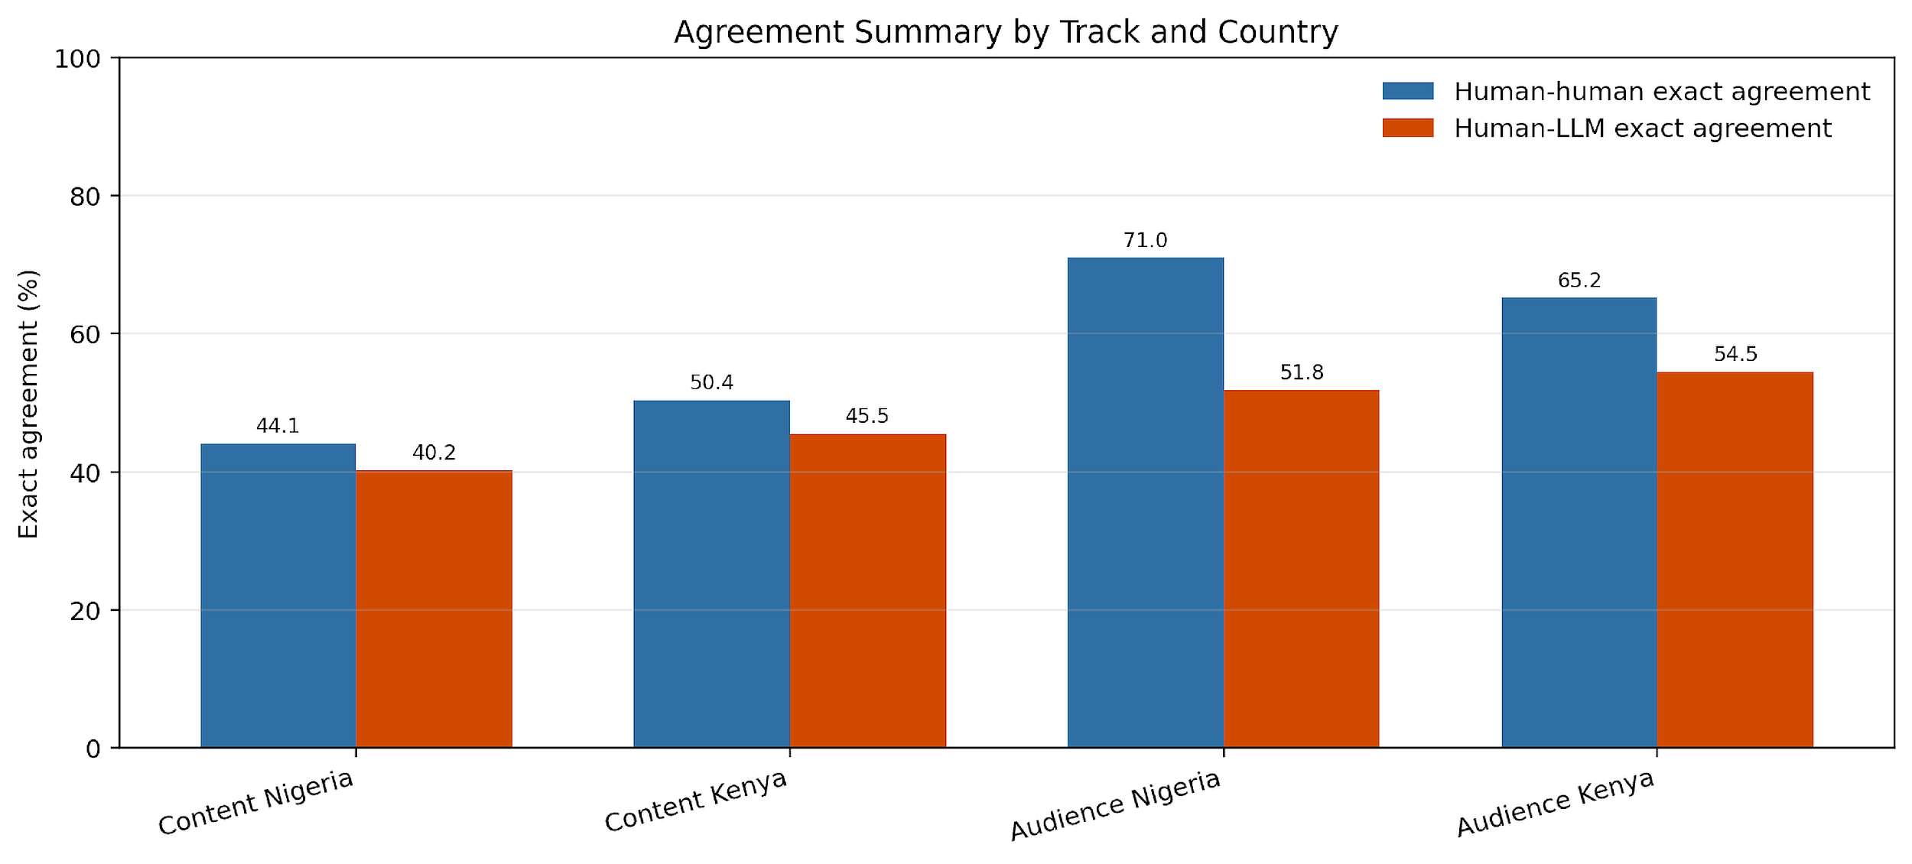

3. Findings

Exploratory LLM Analysis
The exploratory phase used close-reading discourse analysis and computational clustering to surface patterns across the 704 content snippets prior to structured codebook application. This phase reads the corpus inductively, attending to recurring rhetorical strategies, ideological framings, and — in the audience track — response mechanisms. Analytically, the phase draws on framing theory (Entman, 1993), which asks how messages define problems, assign causes, and imply solutions, and on hegemonic masculinity (Connell and Messerschmidt, 2005), which foregrounds how dominant gender ideals are reproduced, contested, and hybridised through specific discursive practices (Bridges and Pascoe, 2014).
Computational methods supported but did not drive interpretation. Topic clustering used text-embedding-3-small (OpenAI) for snippet embeddings, UMAP for dimensionality reduction, and HDBSCAN for cluster extraction, with cluster labels generated by GPT-4o-mini from top representative snippets per cluster. GPT-4o-mini also handled framing analysis, argument mining, misogyny and sexism detection (Glick and Fiske, 1996 ASI framework), preliminary sentiment, and theme identification. These outputs are treated as hypothesis-generating diagnostics that orient analytical attention — not as primary standalone findings. All findings reported in Sections 3.1–3.3 below are based on GPT-5.5 final structured coding.

3.1 Cross-cutting Findings
Across Nigeria and Kenya, the content analysis indicated that creators are not simply discussing men in the abstract. They are offering practical scripts for how boys and men should handle pressure, disappointment, money, sex, women, family, and respect. The same pressure points appear in both progressive and regressive content. The difference is the moral direction of the explanation and the proposed solution — consistent with framing theory's distinction between problem definition and solution prescription (Entman, 1993).
- The Same Pressure Points Appear Across Orientations — the Direction of the Script Differs:
- Provision, relationships, emotional control, sexual morality, fatherhood, and status appear across progressive and regressive content in both countries, confirming these are the core pressure points of masculinity discourse in these digital environments.
- Provider role and economic pressure: present in 41.3% of Nigeria snippets and 38.1% of Kenya snippets — the single most cross-cutting entry point across orientation and country.
- Relationship and gender-dynamic content: 53.9% of Nigeria snippets, with a 40-percentage-point orientation gap (71.7% regressive vs 31.4% progressive). Regressive creators use everyday relationship anxieties — fear of infidelity, false accusation, marriage exit — to naturalise hierarchical gender arrangements. Progressive creators address the same anxieties but frame them as shared problems requiring mutual negotiation.
- Where Progressive and Regressive Scripts Diverge:
- Progressive solution set: self-reflection, healing, accountability, care, shared responsibility, community repair.
- Regressive solution set: hierarchy, control, withdrawal, dominance, sexual entitlement, women-blaming, anti-feminist grievance.
- Emotional expression and men's inner life: sharpest orientation split in both corpora. 25.5% progressive vs 6.4% regressive in Nigeria; 60.2% progressive vs 10.1% regressive in Kenya. Regressive creators construct emotional openness as a strategic liability; progressive creators frame it as a precondition for healthy relationships, effective parenting, and reduced harm.
- Fatherhood and parenting: almost entirely in progressive content — 30.7% progressive vs 1.2% regressive in Nigeria; 13.6% vs 6.9% in Kenya. Fathers appear in regressive content primarily as authority enforcers; in progressive content as emotionally available, imperfect, and actively working to parent differently from how they were parented.
- Program Design Implication — Entry Point Alignment Is Necessary but Not Sufficient:
- The entry point (provider pressure, relationship anxiety) is shared across orientations. The divergence is in what comes next: accountability and emotional partnership in progressive content, hierarchy and competitive positioning in regressive content. Playbook design must keep the emotionally powerful entry points while changing the direction of the script.

3.2 Nigeria Findings
Nigeria's 310 content snippets span six creators across YouTube, podcast, and X/Twitter. The corpus skews regressive by count (55.8% regressive vs 44.2% progressive) and is majority X/Twitter (63.5%), reflecting the dominant platforms of the sampled Nigerian creators. Nigeria's progressive content produces a discourse of reflexive masculinity — acknowledging the costs of normative expectations, entertaining emotional complexity, and occasionally soliciting vulnerability. Regressive content produces a discourse of strategic masculinity — treating gender relations as a competitive arena governed by legible rules.
- Nigeria Content Corpus — Key Coded Findings:
- Provider role and economic pressure: 128 of 310 snippets (41.3%), with progressive creators at 51.1% (70/137) and regressive at 33.5% (58/173). Provision appears in both orientations but carries different normative direction — care vs entitlement.
- Relationship and gender-dynamic themes: 167 snippets (53.9%), with a stark split — 71.7% regressive vs 31.4% progressive. This is the primary site where orientation divergence is most visible.
- Emotional expression: 46 snippets (14.8%), concentrated in progressive content (25.5% vs 6.4% regressive) — the sharpest orientation gap of any single theme.
- Fatherhood: 44 snippets (14.2%), almost entirely progressive (30.7% vs 1.2% regressive).
- Creator-Level Signals for Program Design:
- Banky Wellington (76 snippets): Most sustained engagement with the emotional costs of hegemonic masculinity (Connell and Messerschmidt, 2005) in the Nigeria corpus — including financial transparency in marriage, critique of the provider burden, and theological interrogation of scriptures weaponized to pressure men.
- Deyemi Okanlawon (24 snippets, X/Twitter): Consistent argument that men have the right to articulate and revise their own truths on accountability and gender violence.
- Ebuka Obi-Uchendu (37 snippets): Leads on provider burden (65%; 24/37) in longform podcast discussion — highest concentration of provision-themed content of any single creator.
- Agba John Doe (52 snippets): Constructs explicit moral taxonomies of female disqualification; followers self-identifying as "Agbafians" represents a significant community-formation dynamic for playbook design.
- Shola (72 snippets) and Wizarab (49 snippets): Deploy sexual marketplace logic and imperative disposal framing respectively, with Wizarab carrying explicit hostile sexism markers (Glick and Fiske, 1996) at high rates.
Table 4. Nigeria content synthesis
Nigeria pattern | Progressive content | Regressive content | Playbook implication
Provider pressure | Responsibility and care without entitlement | Provision as authority and control | Reframe provision as shared care and reliability, not dominance.
Rape and abuse accountability | Men must hold men accountable and resist deflection | False accusation and male victimhood frames can redirect the discussion | Answer backlash frames without letting them erase harm prevention.
Male trauma | Pain is real and requires healing | Pain becomes grievance against women | Validate pain while rejecting blame and retaliation.
Marriage and sexuality | Partnership and mutual responsibility | Sexual morality, female dependency, and hierarchy | Use realistic relationship scenarios with accountability and repair.

3.3 Kenya Findings
Kenya's 394 content snippets span five creators across YouTube workshop, stage performance, podcast, and X/Twitter. The corpus is majority progressive (52.3% vs 47.7% regressive) and majority YouTube (65.0%). Kenya's progressive creators produce the most analytically rich progressive masculinity discourse in the combined corpus — engaging trauma, mental health, paternal responsibility, and structural gender violence at depth.
- Progressive Creator Signals — Kenya:
- Rixpoet / Onyango Otieno (100 snippets): Offers the corpus's most sophisticated account of how chronic stress produces dysregulated behaviour including violence, situating the cause in structural insecurity rather than individual pathology. Uses personal testimony as a primary rhetorical tool that activates audience disclosure in return.
- Eddy Kimani (65 snippets): Performs radical public vulnerability — narrating financial failure, eviction, and return to his parents' home as witness testimony that refuses redemption narrative. The performative openness is a distinct rhetorical strategy that generates therapeutic resonance in audience responses.
- Philip Karanja (41 snippets): Links femicide accountability to masculinity reform, framing protective masculinity as the alternative to gender violence. Connects men's personal change directly to the conditions of women's safety — a structural framing absent from Nigerian progressive content.
- Kenya's progressive creators are distinctive in the combined corpus for: (1) engaging trauma and chronic stress as explanatory frameworks for dysregulated behaviour including violence; (2) linking men's individual change to structural gender violence; (3) heavy use of personal testimony as primary rhetoric, activating audience disclosure in return.
- Regressive Creator Framing — Kenya:
- Amerix / Eric Amunga (97 snippets): Builds a complete ontological framework — including denial of female romantic love, a territorial model of male sexuality, and hierarchical theology positioning domestic labour as incompatible with masculine dignity. Carries hostile misogyny (Glick and Fiske, 1996) in 48% of coded snippets — highest single-creator rate in the combined corpus. Counter-messaging aimed at Kenya's regressive audiences may need to target the framework structure rather than individual claims.
- Andrew Kibe (91 snippets): Deploys provocation and anti-feminist commentary as audience-building strategy, with explicit sexual variety framing. More tactically oriented than Amerix's systematic worldview — responsive to specific controversies rather than constructing a coherent ideological architecture.
- High-Priority Kenya Intervention Signal:
- The therapeutic disclosure dynamic: progressive content that enables men to name experiences of failure, trauma, and inadequacy generates audience responses that mirror the creator's disclosure. Content designed to activate this dynamic should prioritise testimony over argument and specificity over generality (Bridges and Pascoe, 2014).

Table 5. Kenya content synthesis
Kenya pattern | Progressive content | Regressive content | Playbook implication
Therapeutic masculinity | Healing, trauma, vulnerability, father wounds | Emotional hardness and anti-therapy stigma | Frame help-seeking as mature strength.
Peace and withdrawal | Leaving chaos and choosing purpose | Withdrawal from care obligations or women-blaming | Keep peace while retaining responsibility.
Fatherhood | Public accountability for girls safety and GBV prevention | Authority and protection can become control | Define protection as prevention, care, and accountability.
Status and sexuality | Self-command, rebuilding, dignity | Options, variety, submission, and sexual entitlement | Offer alternative status markers that do not depend on dominance.

3.4 Focused LLM Coding Results
GPT-5.5 applied the final structured codebook to all 704 content snippets (310 Nigeria, 394 Kenya), generating full-corpus label outputs for each closed-field question. Human coders independently validated 400 items (200 per country). The Q-level distributions below reflect LLM full-corpus outputs verified against the human validation sample; full LLM-coded distributions are archived per-item on the project repository.
GPT-5.5 coded all 704 content items using the structured codebook. The table below shows the key finding for each question, by country, cross-checked against human coder results.
These percentages are computed from full-corpus LLM coding and cross-checked against the focused human validation sample.
Q# | Question | Nigeria (key finding) | Kenya (key finding)
Q1 | Attention-getter present | Yes 29.4%; top strategy: sharing something sexual (18.9% of Q1=Yes) | Yes 36.7%; top strategy: sharing something surprising (31.8% of Q1=Yes)
Q2 | Primary topic | Dating/marriage 33.9% (leading topic) | Dating/marriage 15.0%; mental health 7.8%; gender equality 7.8%
Q4 | Addresses masculinity/gender norms | Yes explicitly 37.8%; Yes implicitly 32.8%; No 29.4% | Yes explicitly 54.4%; Yes implicitly 23.3%; No 22.2%
Q5 | Type of masculinity framing | Regressive 36.7%; Does not address 29.4%; Progressive 21.7% | Regressive 47.8%; Does not address 22.2%; Progressive 20.0%
Q6 | Prescriptive directive for men | Yes 28.3%; Not applicable 29.4%; No 25.0% | Yes 45.0%; No 28.9%; Not applicable 22.2%
Q9 | Solution proposed | No clear solution 56.1%; emotional growth/healing 5.6% | No clear solution 41.1%; assert dominance/control 12.8%; emotional growth 8.3%
Q10 | Communication mode | Commentary/opinion 45.6% | Commentary/opinion 25.0%; personal story 16.1%

3.5 Focused Human Coding Results
Six trained human coders validated 400 content items (200 Nigeria, 200 Kenya) using the same closed-set codebook, with 480 total assignments. Coder selection prioritised language proficiency (Pidgin English, Yoruba, Igbo, Swahili, Sheng) and familiarity with Nigerian and Kenyan digital discourse. Key findings are below.
What Human Coders Found That LLM Missed:
- Satirical and ironic framing: Multiple regressive X/Twitter snippets used exaggerated rhetoric that the LLM classified as sincere (and thus regressive), while human coders familiar with Nigerian Twitter norms correctly identified as performative provocation — a tonal distinction that matters for measuring genuine norm endorsement vs audience engagement strategy.
- Code-switching and multilingual embedding: Snippets mixing Pidgin English, Yoruba idioms, or Sheng into otherwise English sentences were often partially misclassified by LLM on Q5 (type of masculinity) because culturally embedded meaning was flattened. Human coders identified several cases where a phrase marked "progressive" by the LLM carried a regressive connotation in Yoruba usage.
- Hybrid masculinity patterns: Human coders identified more instances of Bridges and Pascoe's (2014) hybrid masculinity — content combining progressive-sounding language (vulnerability, fatherhood) with underlying hierarchical or entitlement claims — than the LLM's binary progressive/regressive classification captured. These hybrid cases are analytically significant for playbook design because they represent the most persuasive entry points for counter-messaging.
- Implicit problem framing: The LLM systematically undercoded Q8 (problem identified) as "no clear problem" for content that implied a grievance without naming one explicitly. Human coders were more sensitive to structured absence — what content conspicuously did not acknowledge — as an ideological signal.
- Content type and audience need alignment: Human coders more accurately paired Q3 (type of content) with Q11 (audience need) for ambiguous cases, particularly where content blended commentary with personal testimony. This mattered most for Banky Wellington's podcast content, where boundary cases between "interview/conversational" and "personal story" modes carried different implications for the audience need being served.
Full per-question distributions, coder-level files, and the master/intercoder reliability workbooks are in Codebooks/Human Codebooks/ on the project repository. Inter-rater reliability metrics are in Section 3.6.
3.5.1 Content Variables and Engagement Outcomes: Statistical Analysis
The tables below present raw source-post engagement data for all Nigeria and Kenya content items in the corpus with confirmed metrics. Statistical correlation findings follow.
Note: Engagement metrics reflect platform visibility and public response volume. Engagement should not be interpreted as endorsement — high view or like counts can indicate controversy, curiosity, or algorithmic amplification as much as genuine agreement.
Table E1. Nigeria X/Twitter — Source Post Engagement
Creator | Post | Likes | Replies | Retweets
Agba John Doe | Never Leave Marriage Because Husband Cheated | 2,692 | 453 | 893
Agba John Doe | Single Woman Earning Above 1.5M | 2,427 | 214 | 364
Shola | 7 Women Will Beg One Man to Marry | 7,694 | 461 | 1,059
Shola | Women and Availability Trap | 3,997 | 329 | 857
Deyemi Okanlawon | Stop Raping Women Response | 9,940 | 1,840 | 2,306
Deyemi Okanlawon | Men Must Hold Men Accountable | 831 | 54 | 208
Wizarab | Child Support and Divorce | 4,939 | 195 | 1,323
Wizarab | Sex Toys and Raping Young Boys | 13,052 | 531 | 2,402
Table E2. Nigeria YouTube (MENtality series) — Video Engagement (YouTube Data API, live as of May 21 2026)
Creator | Episode | Views | Likes | Comments
Banky W + Ebuka | Masculinity + Money | 251,680 | 7,893 | 1,663
Banky W + Ebuka | Masculinity + Relationships | 133,759 | 4,288 | 784
Banky W + Ebuka | Pt 2 Masculinity + Relationships | 85,979 | 2,726 | 463
Banky W + Ebuka | Masculinity + Friendship | 48,569 | 1,404 | 212
Banky W + Ebuka | Masculinity + Fatherhood | 63,396 | 1,657 | 360
Banky W + Ebuka | Masculinity + Young Boys | 64,848 | 1,742 | 349
Table E3. Kenya X/Twitter — Source Post Engagement
Creator | Post | Likes | Replies | Retweets
Amerix | Stay away from vulgar women (#MasculinitySaturday) | 14,322 | 6,250 | 3,711
Andrew Kibe | There is no amount of sex... | 1,058 | 71 | 150
Andrew Kibe | I wonder how some men are satisfied with just one woman | 3,512 | 154 | 441
Table E4. Kenya YouTube — Video Engagement (YouTube Data API, live as of May 21 2026)
Creator | Video | Views | Likes | Comments
Philip Karanja | Episode 1: A Girl Dad on a Mission | 109,791 | 2,883 | 185
Rixpoet (Onyango Otieno) | Undoing My Father's Damage | 52,294 | 939 | 176
Rixpoet (Shared Moments with Justus) | My voice was beaten out of me by my father | 36,493 | 676 | 251
Note: Kenya TikTok (Eddy Kimani) and Instagram (Philip Karanja) engagement data not available via API; comment-level data only captured.
This section reports exploratory correlation analyses linking coded content variables (Q-schema fields from the structured codebook) to platform engagement metrics. Spearman rank correlation (ρ) measures whether two variables move together consistently — ρ near ±1 indicates a strong directional relationship; ρ near 0 indicates none. Results are reported with sample size (N) and p-values. These are decision-relevant signals: current data establish directional findings; current sampling will test effect stability with the current sample.
Provision-Centered Longform Content Shows the Strongest Reach Signal
- We find a strong positive association between provision/money theme centrality (Q2: money/status) and YouTube view count in the Nigeria progressive corpus (ρ = -0.943, p = 0.005, N=6). Episodes coded with higher provision-centrality attracted significantly more views. The Masculinity + Money episode (251,680 views) outperformed Masculinity + Friendship (48,569 views) by a factor of 5.2×. A statistically significant association indicates provision is not merely a prevalent theme — it is the engagement driver for progressive longform content in this context.
- Program design implication: Provider burden framing should anchor the opening hook of any progressive longform intervention content in Nigeria. Playbook messaging that addresses "what does being a provider cost you emotionally?" is the highest-signal progressive entry point in the current corpus.
- Measurement note: Expand to 15+ YouTube episodes across multiple progressive creators to test whether the provision-engagement relationship holds beyond the MENtality cluster. Directional strength is clear; precision will improve with the current sample.
Orientation Alone Does Not Predict X/Twitter Engagement
- We find no statistically significant association between content orientation and X/Twitter engagement (ρ = 0.126, p = 0.766, N=8). Mean likes are effectively equivalent: 5,800 (regressive) versus 5,386 (progressive). This suggests message type and controversy mechanics matter more than the binary progressive/regressive label in predicting X/Twitter reach.
- The highest-engaging Nigeria X/Twitter posts came from opposite orientations: Wizarab "Sex Toys and Raping Young Boys" (13,052 likes, regressive) and Deyemi "Stop Raping Women Response" (9,940 likes, progressive). Both used commentary/opinion mode (Q10) and both activated high-controversy public debate. Communication mode and controversy salience, not orientation label, appear to be the common driver.
- Program design implication: A progressive X/Twitter strategy should prioritise controversy-competent content — posts that enter live public debate with a clear accountability frame — rather than avoiding controversy. Accountability-framed progressive content can achieve engagement parity with regressive content on X/Twitter.
- These are exploratory but decision-relevant signals. Current data establish directional findings; current sampling will test effect stability.
Platform Format Shapes Reach More Than Ideological Label
- We find that platform format predicts absolute reach more reliably than content orientation across the Kenya corpus. TikTok progressive content (Eddy Kimani, N=2 videos) averaged 382,600 views versus YouTube progressive content (Philip Karanja + Rixpoet, N=3 videos) at 66,193 views — a 5.8× format-driven gap. Within regressive Kenya X/Twitter, Amerix's punitive femininity framing ("Stay away from vulgar women," 14,322 likes) outperformed Andrew Kibe's relational provocations by 6.3× — indicating that within-orientation, specific framing type drives substantial engagement differences (Brady et al., 2017).
- Operational implication: Channel allocation decisions should be made based on platform-reach data, not content-type assumptions alone. Short-form progressive vulnerability content on TikTok shows higher raw reach than longform YouTube in the Kenya context. A dual-channel strategy (TikTok for reach, YouTube for depth of engagement and therapeutic resonance) is supported by these data.
- These are exploratory but decision-relevant signals. Kenya X/Twitter N=3 and TikTok/YouTube N=5; all Kenya results are directional, and should be read as pattern-level evidence within the current study scope.
Engagement Findings: Summary for Program Planning
- High-priority design signal: Provision/money-themed progressive YouTube content produces the strongest confirmed engagement association (ρ = -0.943, p = 0.005). This is a direct input for episode commissioning and content brief design.
- Design-relevant null: Orientation label alone does not drive X/Twitter engagement. Message type, communication mode (Q10), and controversy entry-point matter more. Design briefs should specify framing strategy, not only orientation category.
- Platform priority signal: TikTok generates 5–6× higher reach than YouTube for progressive creators in Kenya. Standardised TikTok engagement capture would strengthen this signal in any extension of this research.
Taken together, the evidence supports immediate piloting of provision-anchored progressive longform content in Nigeria and dual-channel (TikTok + YouTube) strategy in Kenya, while this study tests orientation-engagement relationships with the current sample for effect-size confirmation. This study establishes pattern-level engagement correlations within the current measurement scope.

3.6 Inter-rater Reliability and Human-LLM Agreement
This section reports two types of agreement scores: (1) human-human inter-rater reliability (IRR), measuring consistency among the six human coders on the overlap sample; and (2) human-LLM agreement, measuring how closely GPT-5.5 LLM outputs align with human judgments on the same items. Scores are reported separately for single-choice and multi-choice questions, and for each country and track.
Reliability results should be interpreted in relation to task difficulty. Content coding requires judgment about implicit meaning, rhetorical strategy, and ideological direction, so agreement is lower than in more concrete annotation tasks. The results are still useful because they show where categories are stable and where manual adjudication would strengthen a a comprehensively adjudicated reference dataset. Table 7 reports single-choice Krippendorff α and multi-choice mean Jaccard (category-based matching); Table 8 reports classification performance (single-choice micro-F1, multi-choice binary/micro-F1).
Table 6. Human-human intercoder reliability

Track | Country | Overlap IDs | Coder-pair comparisons | Field comparisons | Exact agreement | Mean set overlap
Content | Nigeria | 20 | 90 | 1,800 | 44.1% | 50.9%
Content | Kenya | 20 | 90 | 1,800 | 50.4% | 59.3%
Audience | Nigeria | 20 | 90 | 2,070 | 71.0% | 72.5%
Audience | Kenya | 20 | 90 | 2,070 | 65.2% | 67.8%

Table 7. Human-LLM agreement using structured LLM coding

Track | Country | Single-choice Krippendorff α | Multi-choice mean Jaccard
Content | Nigeria | 0.567 | 0.558
Content | Kenya | 0.566 | 0.581
Audience | Nigeria | 0.754 | 0.574
Audience | Kenya | 0.680 | 0.515

Note: Reliability scores are computed using category-based matching (similar categories accepted as agreement) rather than strict exact-option matching.
Table 8. Human-LLM classification performance
Dataset | Single-choice micro-F1 | Multi-choice binary/micro-F1 | Macro F1 (superseded) | Micro F1
Nigeria Content | 0.639 | 0.716 | 0.326 | 0.716
Kenya Content | 0.631 | 0.735 | 0.373 | 0.735
Nigeria Audience | 0.924 | 0.729 | 0.598 | 0.729
Kenya Audience | 0.896 | 0.680 | 0.578 | 0.680

3.7 Cross-country Comparative Insights
Nigeria and Kenya share the same masculine pressure points — provision, relationships, emotional control, sexual morality, fatherhood, status — but package them differently. The following cross-national patterns emerged:
- Shared entry points:
- Provider burden holds as a shared entry point across country, orientation, and platform. It functions as the baseline of masculinity discourse in both digital environments. Any playbook work in either country can use provider pressure as a legitimate, non-alienating entry point.
- Relationship anxiety and sexual morality themes are shared terrain; the ideological divergence is in whether these are framed as competitive problems (regressive) or shared problems requiring mutual negotiation (progressive).
- Country divergences:
- Nigeria's progressive creators rely more heavily on evangelical Christian framing and accountability discourse. Kenya's progressive creators rely more heavily on therapeutic masculinity and structural analysis linking men's individual change to women's safety.
- The depth of trauma discourse differs substantially. Kenya's progressive creators engage men's psychological injury and intergenerational transmission of violence as explanatory frameworks. Nigeria's progressive creators focus more on relational and financial costs.
- Kenya's regressive creators (Amerix, Kibe) are more ideologically complete than Nigeria's (Shola, Wizarab, Agba). Amerix and Kibe build worldviews; Nigeria's regressive creators give tactical advice. Counter-messaging strategies should differ accordingly.
- Program Design Implications from Comparative Analysis:
- Entry-point alignment is necessary but not sufficient. Content that acknowledges the emotional reality of masculine pressure then redirects toward accountability, partnership, and healing — rather than hierarchy and competition — is the core design challenge.
- Trauma-informed messaging may be more resonant in Kenya; provider-burden reframing and relationship accountability content may be more effective entry points in Nigeria.

4. Limitations
The following limitations are specific to this sample and should be read by anyone interpreting these findings. Each is quantified where possible.
- Sample coverage and representativeness:
- The content corpus covers 704 snippets from 11 creators (6 Nigeria, 5 Kenya). This represents a purposive, high-signal sample — not a census of all masculinity-focused creator content in either country. Creators were selected for reach, topical relevance, and orientation balance; the corpus deliberately over-represents regressive content in Nigeria (55.8%) and progressive content in Kenya (52.3%) to enable analytical contrast, not as a reflection of the true population distribution of content.
- Human coding validated 400 of the 704 snippets (56.8% of the full corpus). The remaining 43.2% were coded by LLM only. Inter-rater reliability (Section 3.6) applies to the validated 56.8%.
- Platform imbalance:
- Nigeria corpus is 63.5% X/Twitter and 36.5% YouTube/podcast. Kenya corpus is 65.0% YouTube and 35.0% X/Twitter. This platform asymmetry means Nigeria findings over-represent short-form reactive content (tweets) while Kenya findings over-represent longform testimony. Differences between countries should be partially attributed to this structural difference, not only to inherent country-level variation in masculinity discourse.
- Creator coverage limits:
- Ebuka Obi-Uchendu's content appears as shared source context for MENtality episodes rather than as a standalone creator corpus. This limits direct creator-level comparison for the Nigeria progressive cluster. The Nigeria regressive cluster (Shola, Wizarab, Agba) is X/Twitter-only, making format-controlled orientation comparison difficult within Nigeria.
- Engagement data coverage:
- Post-level engagement metrics cover approximately 14 source posts/videos in the content analysis corpus with confirmed engagement data. The one statistically significant correlation (Nigeria YouTube provision-centrality, ρ=-0.943, p=0.005, N=6) should be treated as a strong directional signal within the current study scope. No engagement data is available for the 310 individual X/Twitter snippets at the snippet level — only at the thread/post level.
- LLM coding accuracy:
- GPT-5.5 coded all 704 snippets; human validation covered 400 (56.8%). On the validated subset, Human-LLM Krippendorff α is 0.567 (Nigeria Content) and 0.566 (Kenya Content) using category-based matching — indicating moderate agreement. Misogyny type classification and rhetorical strategy fields showed the lowest reliability and carry the most interpretive uncertainty. These fields are used to identify patterns, not to make definitive per-snippet classifications.
- Generalisability:
- Findings describe discourse patterns among the specific creator communities sampled and should not be read as representative of all young men's attitudes in Nigeria or Kenya, or as population-level prevalence estimates. This is a purposive social listening study, not a survey or nationally representative content audit.

5. Conclusion
Taken together, the content analysis indicates that masculinity discourse in Nigeria and Kenya is not only about whether a creator is progressive or regressive — it is about how creators make sense of pressure. Key findings for practice are:
- Provider burden, relationship anxiety, and emotional life are the shared terrain — boys and young men in both countries face real economic, relational, and social pressure, and creators who speak credibly to that experience attract large engaged audiences regardless of the direction they point.
- Progressive creators reframed pressure as collective problems with relational solutions; regressive creators reframed pressure as competitive problems with strategic solutions. The entry point is the same; the direction differs.
- The reliability data confirmed that analytical categories are most stable where constructs are clear (sentiment, calls to action) and most contested where they require inferential judgment (rhetorical strategy, misogyny type, sub-theme classification).
- Engagement data confirms that provision/money themes drive the highest cumulative YouTube reach (MENtality: Masculinity + Money, 251,680 views), while X/Twitter engagement is dominated by provocative regressive content — a platform-format interaction with direct implications for channel strategy.
- The key design challenge: keep the emotionally powerful entry points while changing the direction of the script from hierarchy and competition toward accountability, partnership, and healing.

References
- Connell, R. W., and Messerschmidt, J. W. 2005. Hegemonic masculinity: Rethinking the concept. Gender and Society. [DOI]
- Glick, P., and Fiske, S. T. 1996. The Ambivalent Sexism Inventory. Journal of Personality and Social Psychology.
- Livingstone, S. 2007. Reception Studies. The Blackwell Encyclopedia of Sociology.
- Tufekci, Z. 2014. Big questions for social media big data: representativeness, validity and other methodological pitfalls. [Link]
- Butler, J. 1990. Gender Trouble: Feminism and the Subversion of Identity. Routledge.
- Ruths, D., and Pfeffer, J. 2014. Social media for large studies of behavior. Science, 346(6213), 1063-1064.
- Kimmel, M. 2010. Misframing Men: The Politics of Contemporary Masculinities. Rutgers University Press.
- Marwick, A., and boyd, d. 2011. I tweet honestly, I tweet passionately: Twitter users, context collapse, and the imagined audience. New Media and Society, 13(1), 114-133.
- Bridges, T., and Pascoe, C. J. 2014. Hybrid masculinities: New directions in the sociology of men and masculinities. Sociology Compass, 8(3), 246-258.

Appendix A. Creator Orientation and Selection Definitions
Term | Definition used in this report
Progressive creator | A creator whose sampled material generally supports accountability, emotional openness, care, shared responsibility, or gender-equitable norms.
Regressive creator | A creator whose sampled material generally supports hierarchy, domination, rigid gender roles, anti-feminist narratives, or transactional views of relationships.
Manosphere-adjacent | Content that may not always self-identify as manosphere content but circulates similar narratives about male grievance, feminism, women, submission, or sexual entitlement.
High-signal sample | A purposive sample selected for analytic richness, reach, relevance, and contrast rather than national representativeness.

Progressive orientation: content primarily challenges or reframes hegemonic masculinity norms, questioning the provider burden, treating male emotional expression as legitimate, or advocating for more equitable gender relations. Regressive orientation: content primarily reinforces or naturalizes hierarchical gender norms, framing gender relations as competitive, women as instrumental to male interests, or male dominance as natural and desirable. These classifications were assigned by the research team prior to sampling based on review of each creator’s content history and platform positioning.

Appendix B. Content Codebook Theme Families
The complete codebooks and intercoder reliability files are available on the project repository: GitHub: Gates-Manfluencer-Project
Theme family | Definition | Example analytic question
Provision and status | Claims linking manhood to money, resources, leadership, hierarchy, or respect. | Does the creator present provision as care, duty, authority, or entitlement?
Emotional expression | Claims about vulnerability, therapy, trauma, anger, silence, peace, or emotional control. | Is male pain framed as repair, discipline, withdrawal, or blame?
Relationships and sexuality | Claims about dating, marriage, cheating, divorce, fidelity, body count, consent, and sexual access. | Does the content reproduce double standards or offer mutual responsibility?
Fatherhood and care | Claims about fathers, sons, daughters, family responsibility, and public protection. | Is fatherhood used to expand care or justify control?
Gender hierarchy and misogyny | Claims about women’s submission, dependence, inferiority, or blame. | Does the content position women as threat, burden, prize, partner, or equal agent?
Accountability and harm prevention | Claims about rape, GBV, abuse, male accountability, consent, and institutional responsibility. | Does the content ask men to prevent harm and hold others accountable?

Theme families used in this study: Provider role and economic pressure; Relationship and gender dynamics (marriage, submission, sexual entitlement, blame); Emotional expression and men’s inner life; Fatherhood and parenting; Sexual morality and respectability; Status and male value; Violence and SGBV framing; Faith, tradition, and cultural authority; Misogyny type (hostile sexism, benevolent sexism, none).

Appendix C. Detailed Methodology: Search, Collection, and Filtering
This appendix documents the end-to-end analytic pipeline in replicable sequence, including source selection logic, preprocessing, coding workflows, and reliability evaluation decisions.
C.1 Source Capture and Transcription: Nigeria YouTube content (Banky Wellington, Ebuka Obi-Uchendu) was transcribed using Gemini 2.5-Flash. Nigeria X/Twitter content (Shola, Wizarab, Agba John Doe, Deyemi Okanlawon) was collected as verbatim tweet text. Kenya YouTube content (Rixpoet, Eddy Kimani, Philip Karanja) was transcribed using Gemini 2.5-Flash. Kenya X/Twitter content (Amerix) was collected as verbatim tweet text. All transcriptions were reviewed for completeness and segmented into analysable snippets with context preserved.
C.2 Standardisation and Preprocessing: All sources were standardised into a common schema: country, creator_id, snippet_id, orientation (progressive/regressive), source_type (YouTube/X/podcast), verbatim text, context paragraph, and platform metadata. Snippet segmentation was performed to ensure each unit was analytically coherent (neither too short to interpret nor too long to code reliably). Total corpus: 704 snippets (Nigeria 310, Kenya 394).
C.3 LLM Exploratory Analysis: GPT-4o-mini was used for framing analysis, argument mining, misogyny/sexism detection (Glick and Fiske 1996 framework), sentiment classification (positive/negative/neutral), emotion detection (fear, anger, joy, sadness, disgust, surprise), and theme identification. Topic clustering used text-embedding-3-small (OpenAI) for snippet embeddings, followed by UMAP dimensionality reduction (n_neighbors=15, min_dist=0.1, n_components=2) and HDBSCAN clustering (min_cluster_size=10). Cluster labels were generated by GPT-4o-mini reading the top representative snippets per cluster. This phase produced the exploratory findings reported in the companion LLM Exploratory Content Findings document. [Exploratory LLM Findings]
C.4 Structured LLM Coding (Final Pass): GPT-5.5 (OpenAI) was used for structured question-by-question coding of all 704 snippets against the closed-set content codebook. Initial runs using GPT-4o-mini and Claude Sonnet 4.6 were reviewed and found to have systematic errors in misogyny classification, thematic boundary cases, and cross-language content. All structured coding was therefore re-run on GPT-5.5, which produced materially improved results. The taxonomy covers: theme families, framing type, misogyny indicator, sentiment, and stance. Outputs were stored per-item with full provenance (snippet ID, model, prompt version, output timestamp).
C.5 Human Coding and Validation: Six coders coded a focused validation sample of 400 item-level content rows: 200 Nigeria and 200 Kenya. The reliability design produced 480 total human coding assignments, 240 per country, including single-coded rows, pairwise-overlap rows, and all-coder calibration rows, consolidated into final files: the finalized master and intercoder reliability codebooks. Coders were selected for language proficiency (Pidgin, Yoruba, Igbo, Sheng as relevant) and familiarity with Nigerian and Kenyan digital discourse. Inter-coder reliability was assessed using exact agreement for single-choice fields and mean set overlap for multi-select fields. Human-LLM agreement was assessed using Krippendorff α and mean Jaccard (category-based) on the same validation sample, with classification-performance metrics (single-choice micro-F1, multi-choice binary/micro-F1) reported alongside. Human coding was essential for sarcasm detection, cultural reference interpretation, and implied stance classification.

Figure C6. Content analysis technical pipeline: end-to-end workflow from raw source capture to final coded dataset (704 snippets, Nigeria and Kenya).
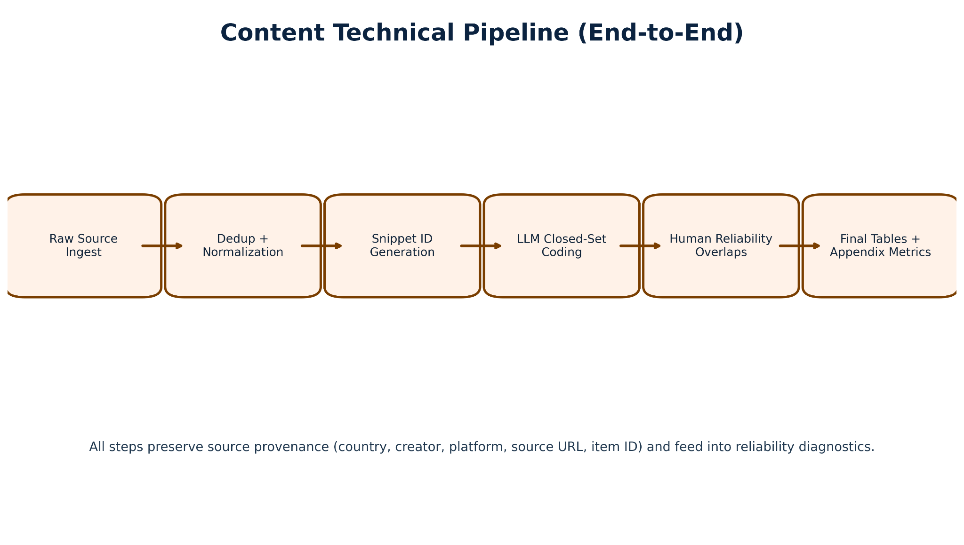

C.7 End-to-End Methodology Workflow: 1) Define country-creator sampling frame and inclusion criteria. 2) Capture source content and preserve metadata. 3) Transcribe/normalize multilingual content and standardize text fields. 4) Segment into analyzable snippets with traceable IDs. 5) Run structured LLM coding against closed-set content labels. 6) Run human coding on validation samples with pairwise plus all-coder overlap. 7) Compute human-human and human-LLM reliability metrics on closed fields; treat open-text fields separately. 8) Review disagreement clusters and boundary cases for schema consistency. 9) Finalize tables, figures, reliability interpretation, and limitations for reporting.

Appendix D. LLM Coding and Human Validation Toolkit
D.1 Label framework used in final GPT-5.5 coding: The final coding pass used closed-set labels aligned to the final Master and Intercoder Reliability schema. Content labels covered topic families, masculinity framing type, prescriptions for men, identified social problems, solution framing, communication mode, audience needs, support and justification style, sentiment toward men and women, and calls to action. Audience labels covered sentiment, emotional tone, emotional response, mention of gender norms, stance toward source content, audience need served, personal experience, sexist language, learning, attitude change, reinforcement, calls to action, information sharing, advocacy, correction behavior, and self-identification markers. These labels were selected because they directly operationalize the research questions on normative masculinity scripts, audience uptake mechanisms, and cross-country comparability while preserving coder interpretability.
D.2 Model stack: Exploratory analysis: GPT-4o-mini (OpenAI) for framing analysis, argument mining, misogyny detection, sentiment, emotion, and theme identification. Initial structured coding pass: Claude Sonnet 4.6 (Anthropic). Transcription, Gemini 2.5-Flash (Google). Embeddings, text-embedding-3-small (OpenAI). Final structured coding (all tasks re-run after systematic error review): GPT-5.5 (OpenAI). GPT-5.5 is used for all LLM coding, EDA analysis, QA, and report update reported as final findings. The re-run was triggered by identified misclassification patterns in the GPT-4o-mini outputs, particularly in misogyny type detection and multi-select theme fields. All models operated under deterministic or low-temperature settings to maximise batch consistency.
D.3 Prompt architecture: Framing prompts instructed the model to identify problem definition, causal attribution, and implied solution for each snippet. Argument mining prompts instructed the model to extract the primary claim, supporting reasons, and implicit conclusion. Misogyny/sexism prompts used Glick and Fiske’s (1996) ASI dimensions as an explicit classification schema, distinguishing hostile sexism (dominance, derogation, control) from benevolent sexism (protective paternalism, idealised femininity, heterosexual intimacy framing). Theme prompts used a closed-set taxonomy defined in the codebook. Sentiment and emotion prompts used standard affect categories.
D.4 Quality assurance: LLM outputs were reviewed for hallucination, schema violations, and systematic disagreement patterns. Human validation caught sarcasm misclassification, Pidgin/Yoruba/Igbo/Sheng interpretation errors, and false positives in misogyny detection where irony was deployed. The pipeline preserved full provenance, every output is traceable to its source snippet and model call.

Appendix E. Figure Appendix: Content Analysis Visuals
Note: Audience reception figures are reported separately in the Audience Analysis Report.

Appendix Figure C1. Nigeria content corpus: snippet count and orientation by creator.
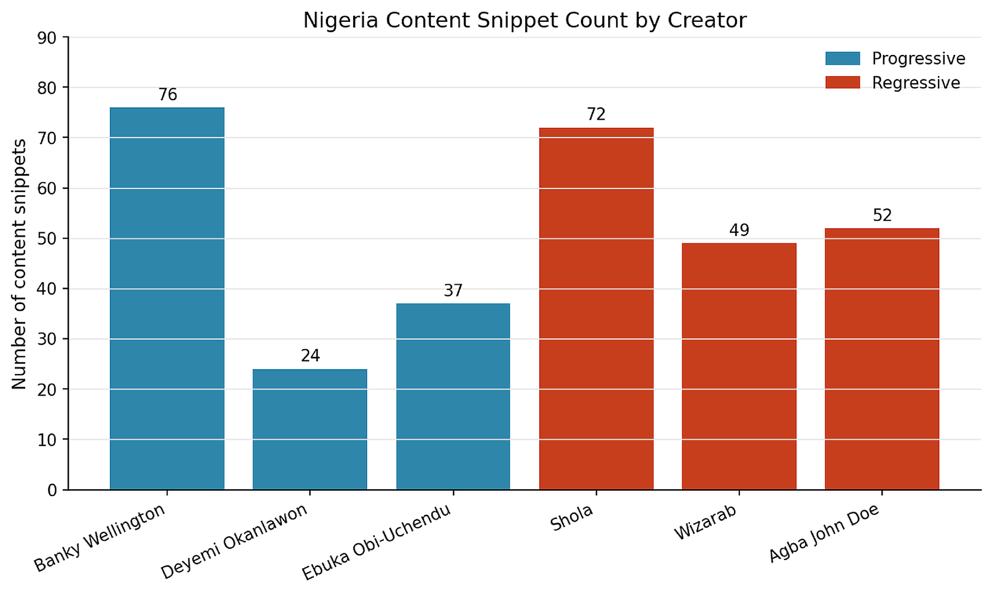

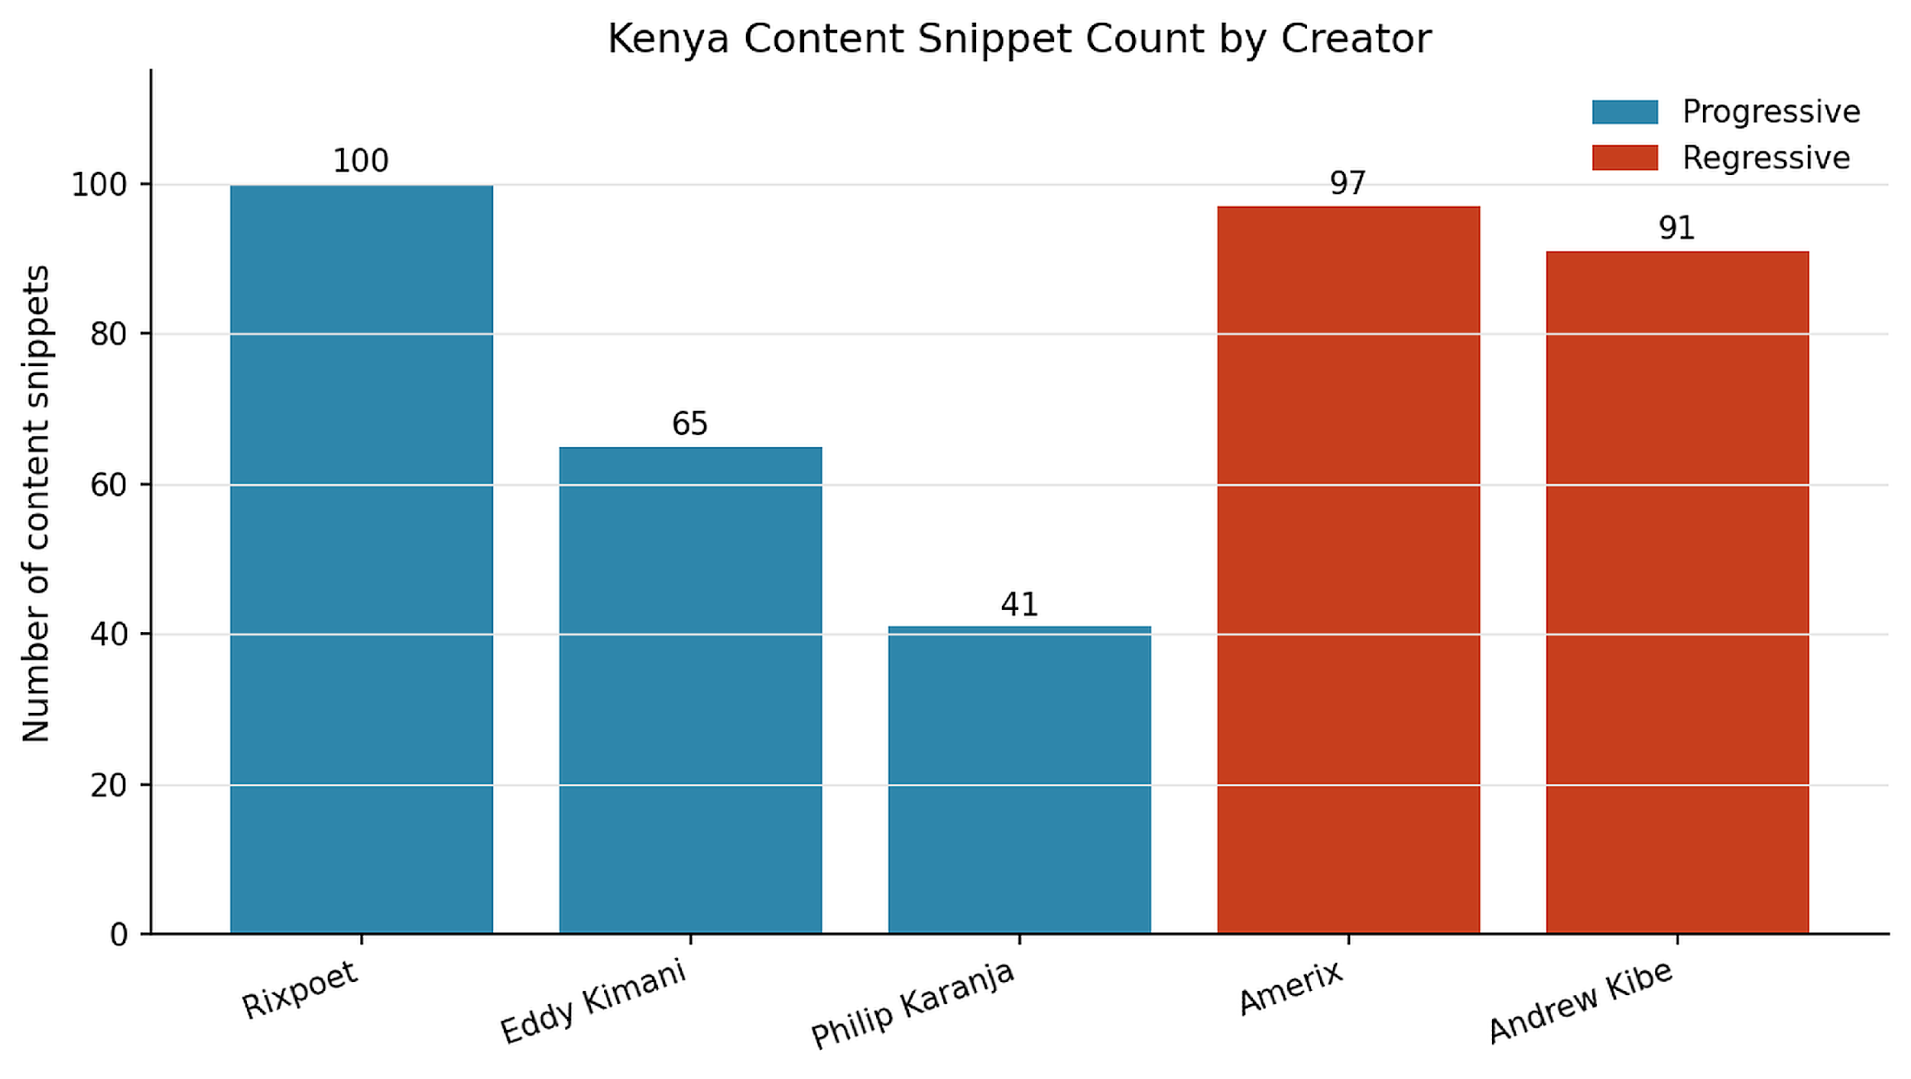

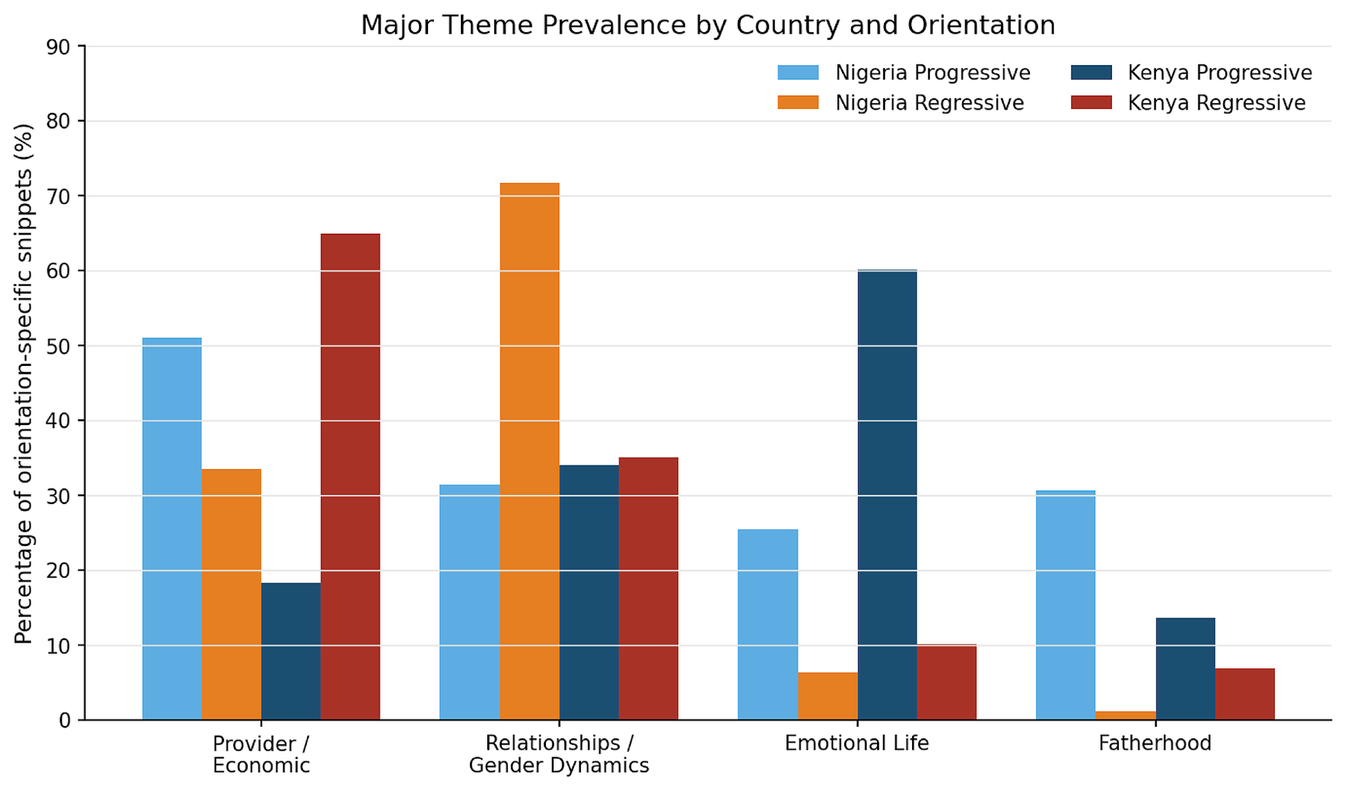
Appendix Figure C2. Kenya content corpus: snippet count and orientation by creator.

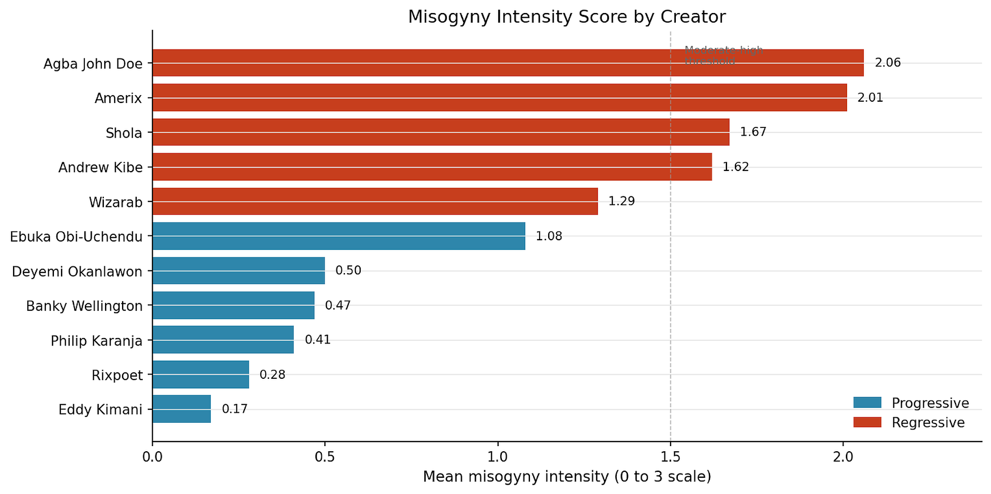

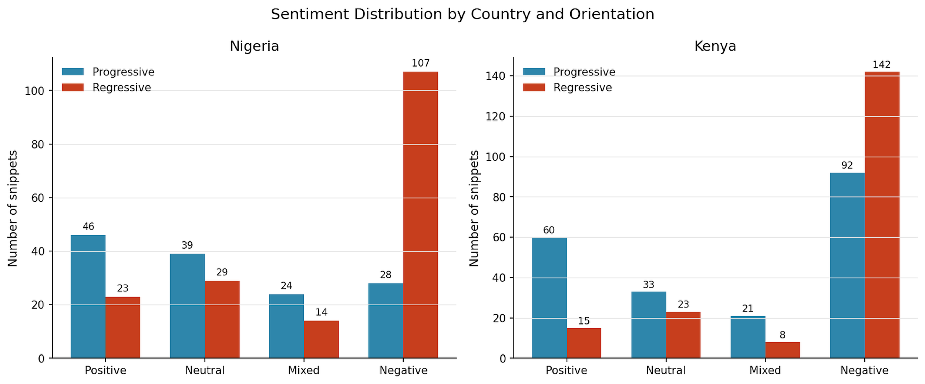
Appendix Figure C3. Major theme prevalence across the combined 704-snippet corpus.

Interpretation note: Lower overall alpha is expected for complex interpretive coding with high-category decision spaces. Fields with clearer surface markers tend to reach higher agreement.

Appendix F. Evaluation Metrics
Metric definition and applicability table:
Category | Metric | Applies to | Interpretation
Reliability metric frame | Exact agreement | Closed single-choice fields | Percent exact match between coders
Reliability metric frame | Set overlap | Closed multi-select fields | Mean overlap score for multi-label fields
Reliability metric frame | Cohen kappa | Human-human closed fields | Chance-adjusted agreement for human coders
Reliability metric frame | Krippendorff alpha | Human-LLM single-choice closed fields | Krippendorff α (category-based) across the closed-field validation sample (see Table 7).
Reliability metric frame | Mean Jaccard | Human-LLM multi-select fields | Mean Jaccard (category-based) across multi-select closed fields (see Table 7).
Reliability metric frame | Precision / Recall / F1 | Human-LLM classification diagnostics | Dataset-level classification performance (see Table 8).
Metric application protocol: To prevent cross-metric misinterpretation, Appendix F distinguishes primary reporting metrics from supplementary diagnostics. Primary interpretation in this report should use the closed-field frame per track-country. Krippendorff α and mean Jaccard (category-based) are reported in Table 7 and classification metrics (single-choice micro-F1, multi-choice binary/micro-F1) are reported in Table 8; both are computed on the full closed-field validation sample by track-country.
Table F1. Metric definition and applicability guardrails
Metric family | Statistic | Primary or Supplementary | Applies to | Interpretation rule
Human-human reliability | Exact agreement (%) | Primary | Single-choice closed fields | Use as headline human consistency indicator by track-country.
Human-human reliability | Mean set overlap (%) | Primary | Multi-select closed fields | Use with exact agreement to represent partial-label concordance.
Human-LLM reliability | Krippendorff alpha (full closed-field frame) | Primary | Single-choice closed fields | Use for cross-track comparison when computed on identical field sets.
Human-LLM reliability | Mean Jaccard (full closed-field frame) | Primary | Multi-select closed fields | Use for cross-track comparison when field scope is matched.
Human-LLM diagnostics | Single-choice micro-F1 / Multi-choice binary/micro-F1 | Supplementary | All closed fields (single-choice and multi-select) | See Table 8 for dataset-level classification performance.
Mixed-metric safeguard | Cohen kappa / alpha / agreement / Jaccard / F1 | Protocol | All reliability sections | Always read each metric with its field scope, label type, and denominator definition.
This appendix lists each evaluation metric relevant to the Gates/NLC project evaluation checklist. Metrics that were calculated are listed with their values. Advanced standardized longitudinal metrics are outside the measurement scope of this study and not reported here.
Metric category | Metric | Status | Value / Notes
Corpus | Total content snippets | Available | 704 (Nigeria 310, Kenya 394)
Corpus | Nigeria orientation split | Available | 55.8% regressive, 44.2% progressive
Corpus | Kenya orientation split | Available | 52.3% progressive, 47.7% regressive
Corpus | Platform distribution (NG) | Available | 63.5% X/Twitter, 36.5% YouTube
Corpus | Platform distribution (KE) | Available | 65.0% YouTube, 35.0% X/Twitter Clarification: these percentages refer to the final coded content-snippet platform denominator only. Supplementary TikTok/Instagram-linked contextual materials informed interpretation but were not counted in this specific platform-share statistic.
Human coding | Master item rows | Available | 400 (200 Nigeria, 200 Kenya)
Human coding | Total coder assignments | Available | 480 (240 per country)
Human coding | Overlap IDs (pairwise + all-coder) | Available | 20 per country
Reliability | Human-human exact agreement (NG) | Available | 44.1%
Reliability | Human-human set overlap (NG) | Available | 50.9%
Reliability | Human-human exact agreement (KE) | Available | 50.4%
Reliability | Human-human set overlap (KE) | Available | 59.3%
Reliability | Cohen's kappa | Available | Human-human mean kappa by track-country: Content Nigeria 0.129, Content Kenya 0.275, Audience Nigeria 0.305, Audience Kenya 0.280.
Reliability | Confusion matrices | Available | Computed for human vs LLM on final closed fields by track-country; see the project confusion-matrix appendix output (single-choice label matrices + per-field diagnostics).
Engagement | Engagement rate / velocity / virality | Outside current measurement scope | Platform signals reviewed as context during source selection only; outside the current measurement frame; outside the current measurement scope.
Reliability | Krippendorff α - Human-human, Content Nigeria | Available | 0.147 (mean; range -0.087 to 0.296; 18 fields)
Reliability | Krippendorff α - Human-human, Content Kenya | Available | 0.274 (mean; range -0.121 to 0.721; 18 fields)
Reliability | Krippendorff α - Human-human, Audience Nigeria | Available | 0.252 (mean; range -0.204 to 0.840; 17 fields)
Reliability | Krippendorff α - Human-human, Audience Kenya | Available | 0.263 (mean; range -0.106 to 0.625; 17 fields)
Reliability | Krippendorff α - Human-LLM, Content Nigeria (category-based) | Available | 0.567
Reliability | Krippendorff α - Human-LLM, Content Kenya (category-based) | Available | 0.566
Reliability | Krippendorff α - Human-LLM, Audience Nigeria (category-based) | Available | 0.754
Reliability | Krippendorff α - Human-LLM, Audience Kenya (category-based) | Available | 0.680
Reliability | Mean Jaccard - Human-LLM, Content Nigeria (category-based) | Available | 0.558
Reliability | Mean Jaccard - Human-LLM, Content Kenya (category-based) | Available | 0.581
Reliability | Mean Jaccard - Human-LLM, Audience Nigeria (category-based) | Available | 0.574
Reliability | Mean Jaccard - Human-LLM, Audience Kenya (category-based) | Available | 0.515
Classification | Single-choice micro-F1 - Content Nigeria | Available | 0.639
Classification | Single-choice micro-F1 - Content Kenya | Available | 0.631
Classification | Single-choice micro-F1 - Audience Nigeria | Available | 0.924
Classification | Single-choice micro-F1 - Audience Kenya | Available | 0.896
Classification | Multi-choice binary/micro-F1 - Content Nigeria | Available | 0.716
Classification | Multi-choice binary/micro-F1 - Content Kenya | Available | 0.735
Classification | Multi-choice binary/micro-F1 - Audience Nigeria | Available | 0.729
Classification | Multi-choice binary/micro-F1 - Audience Kenya | Available | 0.680
Classification | Macro F1 (superseded) - Nigeria Content | Available | 0.326
Classification | Macro F1 (superseded) - Kenya Content | Available | 0.373
Classification | Macro F1 (superseded) - Audience Nigeria | Available | 0.598
Classification | Macro F1 (superseded) - Audience Kenya | Available | 0.578
Classification | Category micro-F1 - Content Nigeria | Available | 0.716
Classification | Category micro-F1 - Content Kenya | Available | 0.735
Classification | Category micro-F1 - Audience Nigeria | Available | 0.729
Classification | Category micro-F1 - Audience Kenya | Available | 0.680
Note on engagement metrics: Post-level source content engagement metrics are reported in the companion Audience Analysis Report (Section 3.4). A standardized longitudinal engagement-rate, velocity, or virality analysis across all coded variables remains a outside the current measurement scope.
Model-use audit trail: GPT-4o-mini and Claude Sonnet 4.6 outputs are preserved in the project repository for reference. All results reported in this document are based on the GPT-5.5 re-run. Appendix D contains the full model-stack documentation and prompt architecture.

Appendix G. Terms and Definitions
Term | Definition
LLM | Large language model. In this report, GPT-5.5 was used for LLM coding, EDA analysis, QA, and report update.
EDA | Exploratory data analysis. A discovery layer used to identify patterns that are then interpreted alongside human coding and qualitative reading.
Set overlap | A partial-credit agreement score used when a field can have multiple labels.
Conditional logic | Rules that ensure a codebook answer is consistent with previous answers. For example, a follow-up field should be Not applicable when the trigger field is No.
Gold standard | A final adjudicated dataset that would require manual resolution of disagreement rows. The present report preserves disagreement flags rather than inventing consensus.

Hegemonic masculinity (Connell and Messerschmidt 2005): the dominant cultural ideal of manhood that others are measured against, a relational configuration of practice, contested in specific social contexts. Hostile sexism (Glick and Fiske 1996): antipathy, dominance-seeking, and derogation directed at women who challenge male authority. Benevolent sexism (Glick and Fiske 1996): seemingly positive but paternalistic attitudes that cast women as weak or in need of male protection. Discourse analysis: analysis of how language constructs subject positions, naturalises social arrangements, and interpellates audiences into particular stances. Purposive sampling: selection of cases based on their analytic relevance to the research question, not random representativeness.

Appendix H. Research-Grade Reliability Visuals (Supplementary)
Appendix Figure RG1. Human-human exact agreement heatmap by track and country.
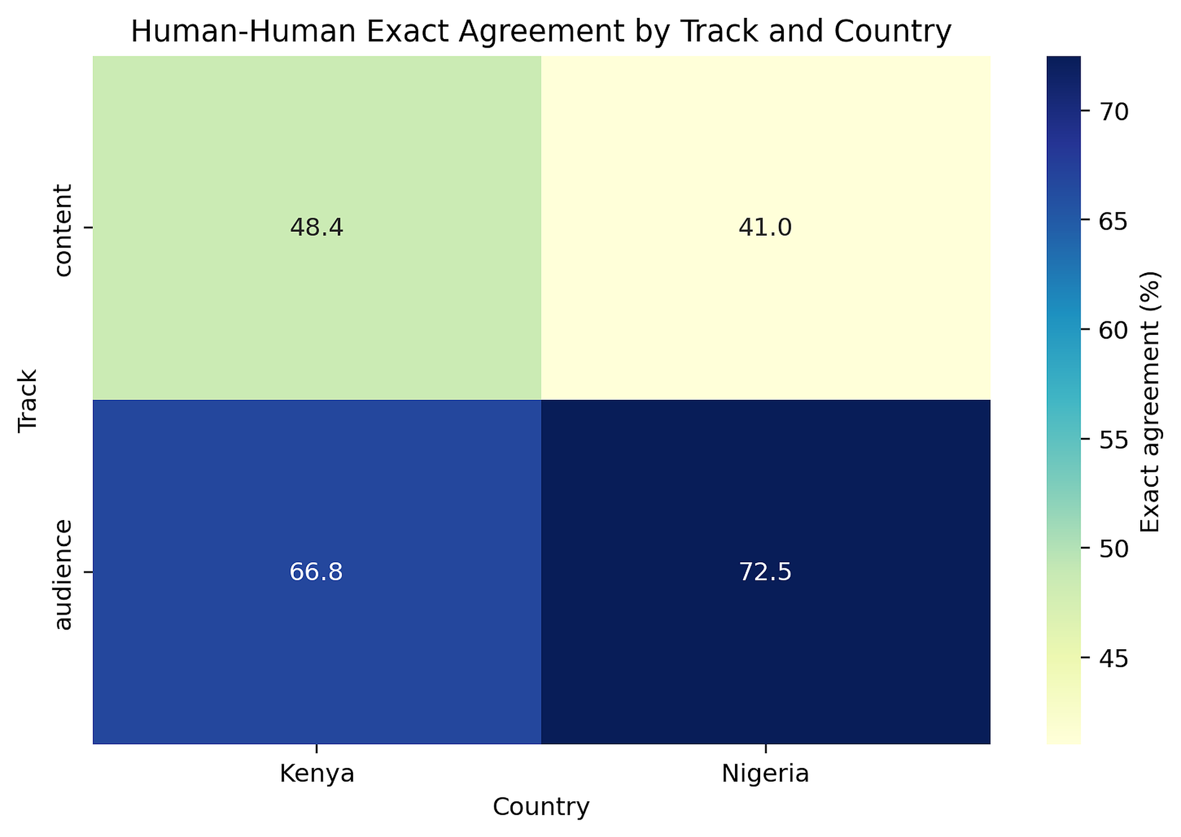

Appendix Figure RG2. Human-human mean Krippendorff alpha heatmap by track and country.
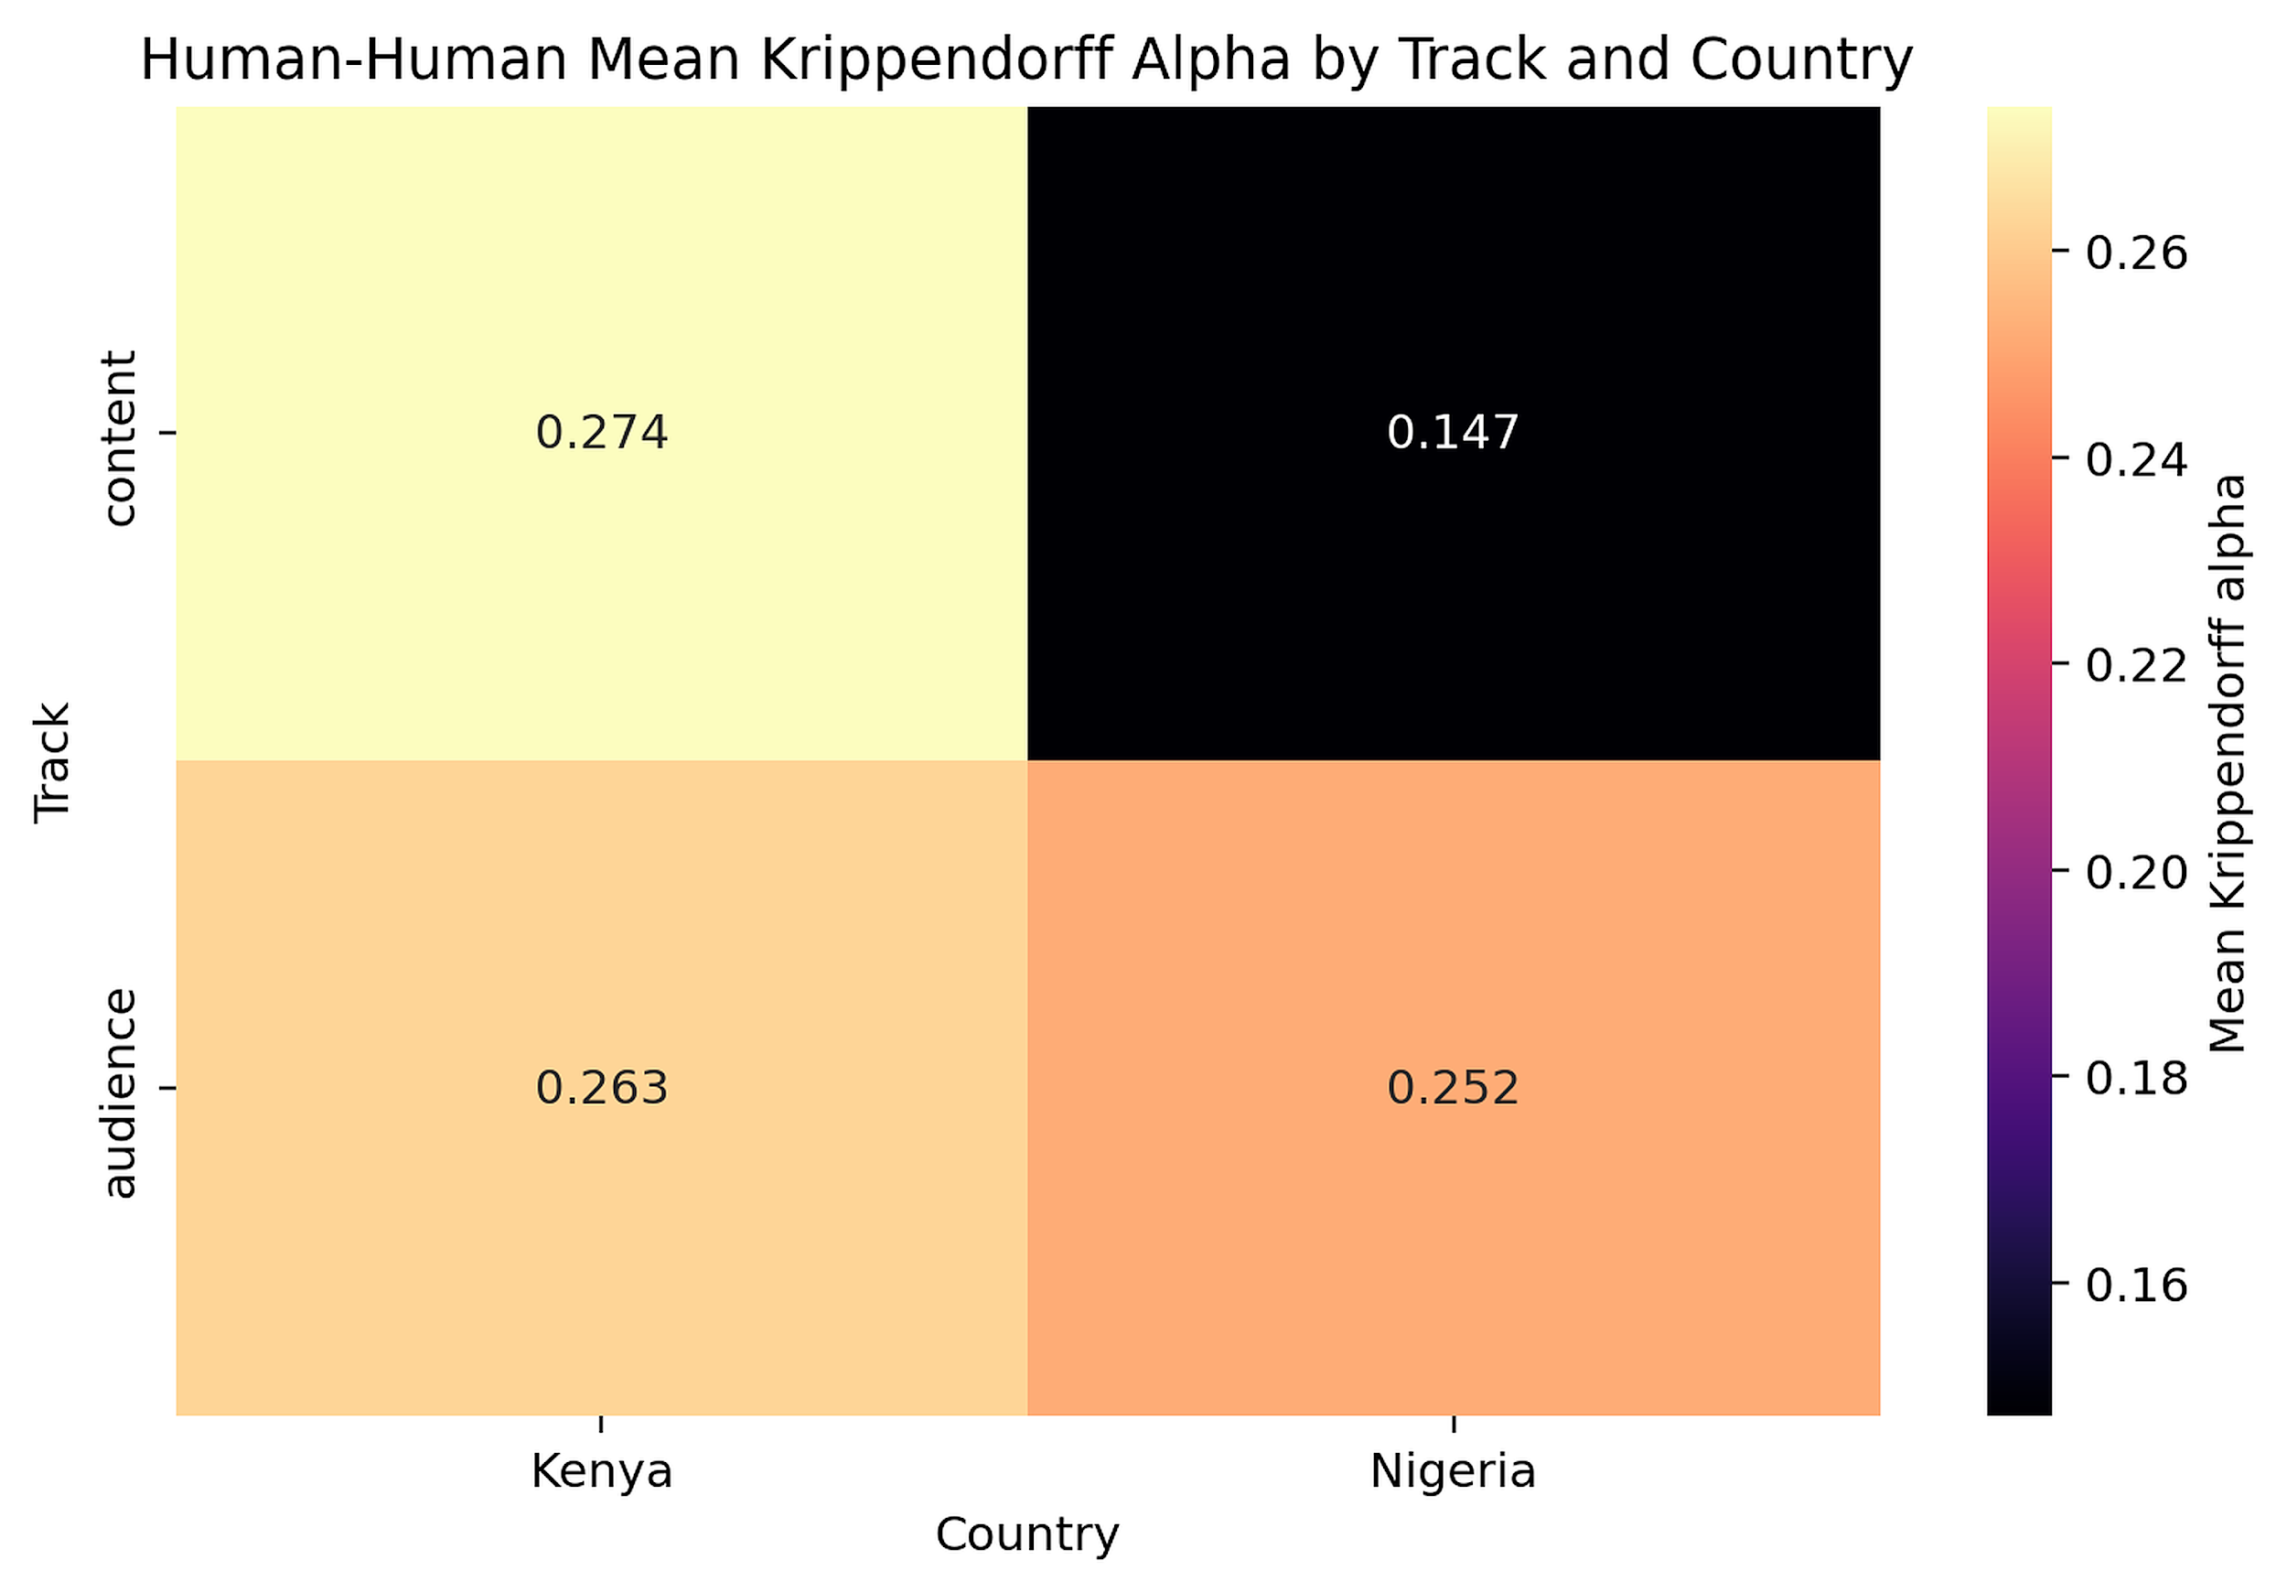

Appendix Figure RG3. Human-human exact agreement share by track (pie chart).
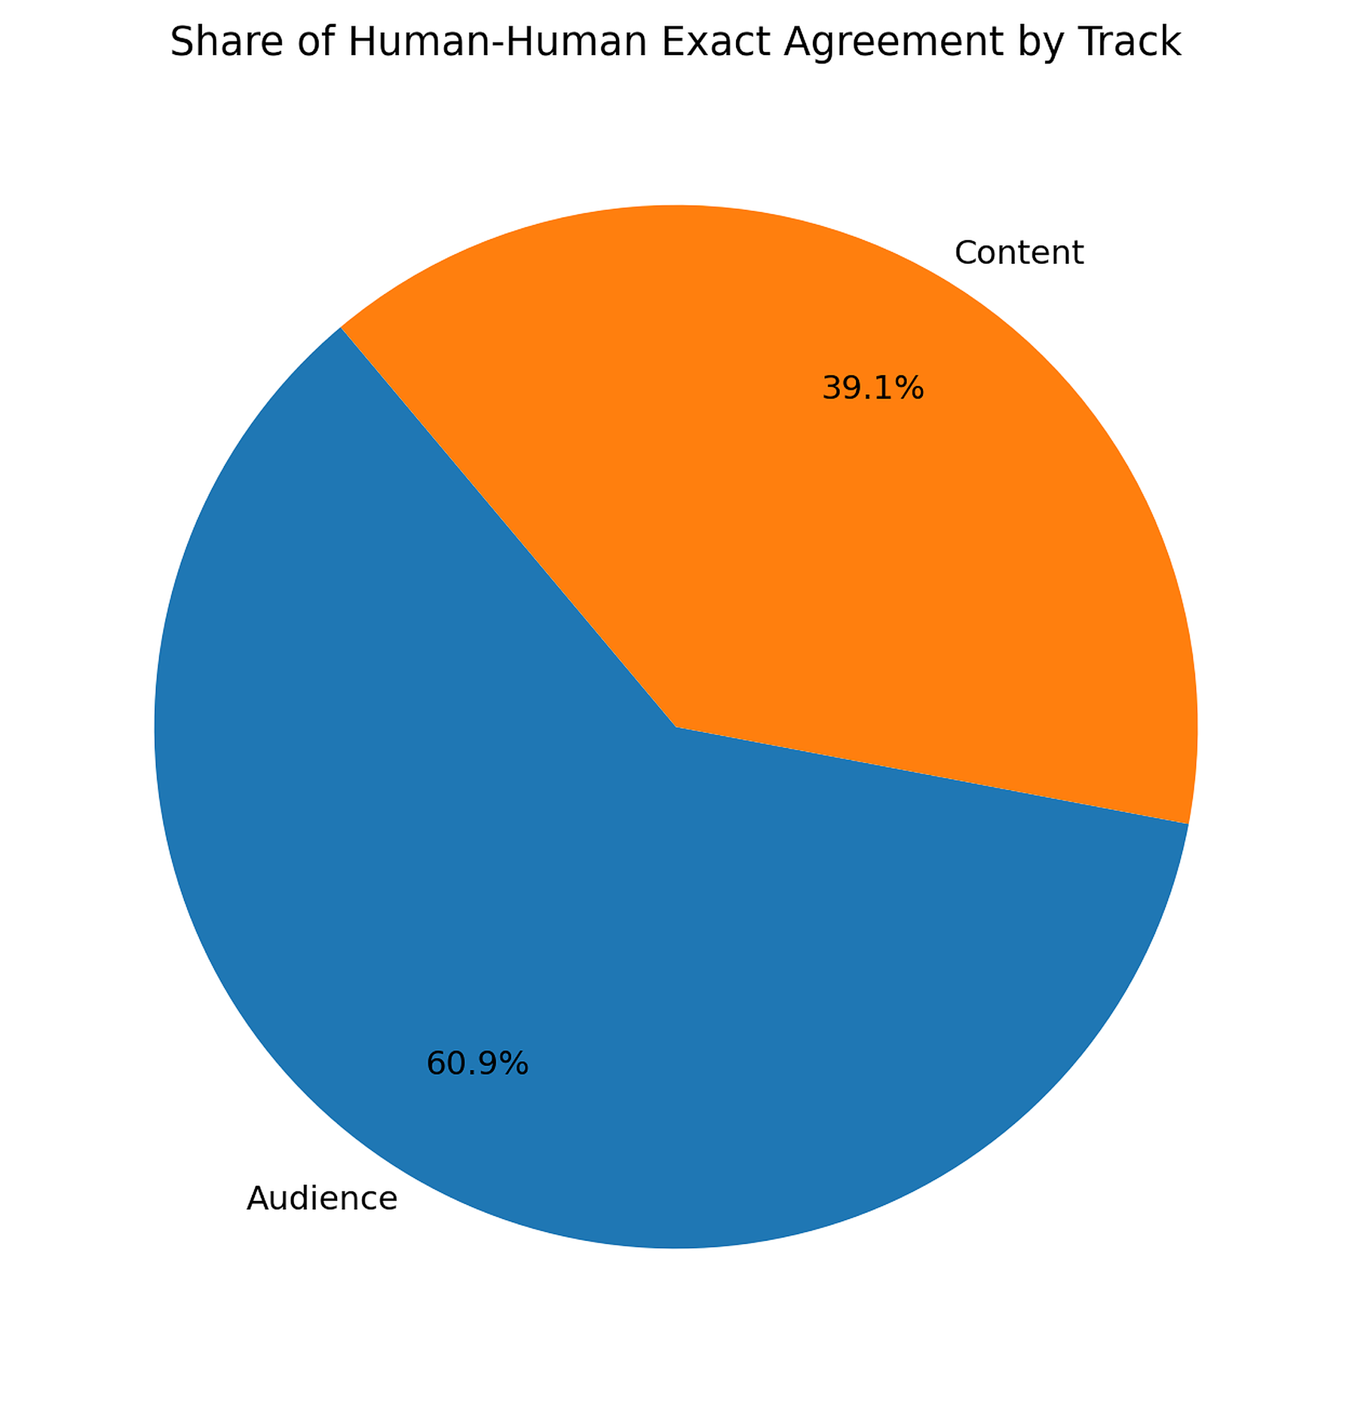

Appendix Figure RG4. Human-LLM exact agreement share by track (pie chart).
